

MINI PROJECT REPORT

On

“IOT BASED HOME AUTOMATION”

Submitted for partial fulfillment of the requirement for

The degree of

Bachelor of Technology

In Electrical Engineering

By

**VISHAL KUMAR (2107350200053**)

**SHIVAM (2107350200044)**

**VIVEK KUMAR (2107350200055)**

Under the supervision of

Dr. Navneet kumar, Assistant Professor

Er. Suneel kumar, Assistant Professor

(Department of Electrical Engineering)

**RAJKIYA ENGINEERING COLLEGE, BIJNOR**

Dr. A.P.J. Abdul Kalam Technical University, Lucknow, U.P. (India)

**ACKNOWLEDGEMENT**

We hereby, completing this project, would like to express our very great appreciation to Mr. Suneel Kumar (Asst. Prof.) for providing required guidance and his valuable and constructive suggestions during our project work. His willingness to give his time so generously has been very much appreciated.

We would also like to thank our friends for their timely help comment and suggestions. Their suggestions and comments had really given me new direction to think on project.

Lastly, we would like to extend our gratitude to authors of the papers and information sources without which this project would not have been possible.

The Faculty of Rajkiya Engineering College, Bijnor has provided us with the knowledge and assistance that constructed the foundation required in us to initiate and follow through a project such as this, and for that we are grateful to all the teachers, officers, and staff of the EE Department. Finally, we would like to express our gratefulness towards our parents and Almighty for being there with us through thick and thin.

**ABSTRACT**

Home automation is a topic which gaining popularity day by day, because of large advantages. One can achieve home automation by simply connecting home appliance electrical devices to the internet or cloud storage. the reason for this surge demand of network enabled home automation is reaching the zenith in recent days for its simplicity and comparable affordability. Platforms based on cloud computing help to connect to the thing surroundings everyone so that one can find it easy to access anything and everything at any time and place in a user friendly manner using custom defined portals. Hence, cloud act as a front end to access IOT. Here we are assuming a system which can control devices through wireless based network or cloud based approach. In this ESP32 project, I have explained how to make an IoT project using ESP RainMaker with Google Assistant & Alexa. With this internet of things project, you can control 8 home appliances with Google Assistant, Alexa, and manual switches. You can also control the relays from Google Home and Amazon Alexa App from anywhere in the world.

And not necessary any Google Nest or Amazon Echo Dot devices for this voice control home automation project.

**LIST OF FIGURES**

Fig.no 1. ESP32 Microcontroller 7

Fig.no 2 4 Channel Relay Module 8

Fig.no 3 Manual Switches 8

Fig.no 4 Buttons 9

Fig.no 5 LED Bulbs 9

Fig.no 6 Bulb Holder 10

Fig.no 7 ESP Rainmaker 10

Fig.no 8 ESP Rainmaker user inter face for app 12

Fig.no 9 ESP Rainmaker Dashboard for web 12

Fig.no 10 Circuit diagram of ESP32 With Relay module 13

Fig.no 11 Code on Arduino IDE 37

Fig.no 12 Compile and uploading code 37

Fig.no 13 Assembled Hardwere 38

Fig.no 14 ESP android and IOS app 38

Fig.no 15 Connecting ESP Rainmaker app by QR Code 38

Fig.no 16 Control our home appliances by using ESP rain Maker app 39

Fig.no 17 Google home android and IOS app 39

Fig.no 18 Connecting this ESP rainmaker app with Google home app 39

Fig.no 19 controlling your home appliances google home 40

Fig.no 20 Amazon Alexa android and IOS app 40

Fig.no 21 Connecting amazon alexa app 40

Fig.no 22 controlling your home appliances Amazon alexa. 41

Fig.no 23 controlling ESP32 from mobile phone UI 41

Fig.no 24 controlling ESP32 from mobile phone voice command 42

Fig.no 25 Flow Chart of ESP Rainmaker 42

Fig.no 26 Service Platforms 43

**INDEX**

Title Page no.

Table of Contents

1 Introduction 6

2 Required Components 7

2.1 ESP32 Microcontroller 7

2.2 Relay Module 4 channel 8

2.3 Switches 8

2.4 Buttons 9

2.5 LED Lights 9

2.6 Bulb Holders 10

2.7 ESP Rainmaker 10

3 Circuit for ESP32 Control 4 Relays 13

4 Program ESP32 With Arduino IDE 14

4.1 Code for Switched (Latched) 14

4.2 Code for Buttons (Momentary) 25

4.3 Code for Change Device Name 36

5 Working 37

6 Flow Chart 41

6.1 Flow Chart of controlling ESP32 from mobile phone UI. 41

6.2 Flow Chart of controlling ESP32 from mobile phone voice command. 42

6.3 Complete Flow Chart of ESP Rainmaker 42

6.4 Service Platforms 43

7 Advantages 43

8 Disadvantages 43

9 Conclusion 44

10 Reference 44

# Introduction

The home animation is control of home device form a central control point automation is today s facts where more things are being completed every day automatically. Usually the basic tasks of turning on or off certain device and beyond, either remotely or in close proximity. The concept of the RF-based system is to use the underlying wireless data network such as IEEE 802.11 (Wi-Fi). The popularity of wireless networks at home has increased in recent years, and the advanced computer technology has made the personal digital device to commonly have the capability to communicate through the wireless network. Hence, it is suitable to use RF-based location determination system to estimate location of the personal digital device in a home environment with high data rate transmission, supporting multimedia application may be feasible in WLAN.

One if the possible application is wireless network for home automation. Imagine a private home equipped with motion light temperature and other sensor actuators for opining the door dimming lights with a remote control as complex as setting up a network of items in your home (such as thermostat, security system lighting and appliances) that can be programmed using a main controller. The basic idea of home automation is to employ sensor and control system to monitor dwelling and accordingly adjust the various mechanism that provide heat ventilation lighting and other service. The automated “intelligent” home can provide a safer more comfortable and more economical dwelling.

In an intelligent home automation system there are many possible solution for how and form where to control the automation system and single device a user interface can be a computer-based system a mechanical switch a single light a loudspeaker with a microphone or a some kind of personal remote controller using normal PC, laptop or table PC by Stand Alone software or web-based user interface. In the near future all electronic appliances in a home will be networked. The internet of things (IOT) is the network of physical objects or “Things” embedded with electronics, software, sensors and network connectivity, which enable these objects to collect and exchanging data. IOT allows objects to be sensed and controlled remotely across existing network infrastructure, creating opportunity for more direct integration between the physical world and Computer based system, and resulting in improve efficiency, accuracy and economic benefits.

# Required Components

## ESP32 Microcontroller

ESP32 is already integrated antenna and RF, power amplifier, low-noise amplifiers, filters, and power management mode. The entire solution takes up the least amount of printed circuit board area. This board is used with 5 GHz dual-mode Wi-Fi and chips by TSMC 40nm low power technology, power and RF properties best, which is safe, reliable, and scalable to a variety of applications.

**Features:**

* High performance-price ratio
* Small volume, easily embedded to other products
* Strong function with support LWIP protocol, RTOS
* Supporting three modes: AP, STA, and AP+STA
* Supporting Arduino program, easily to develop

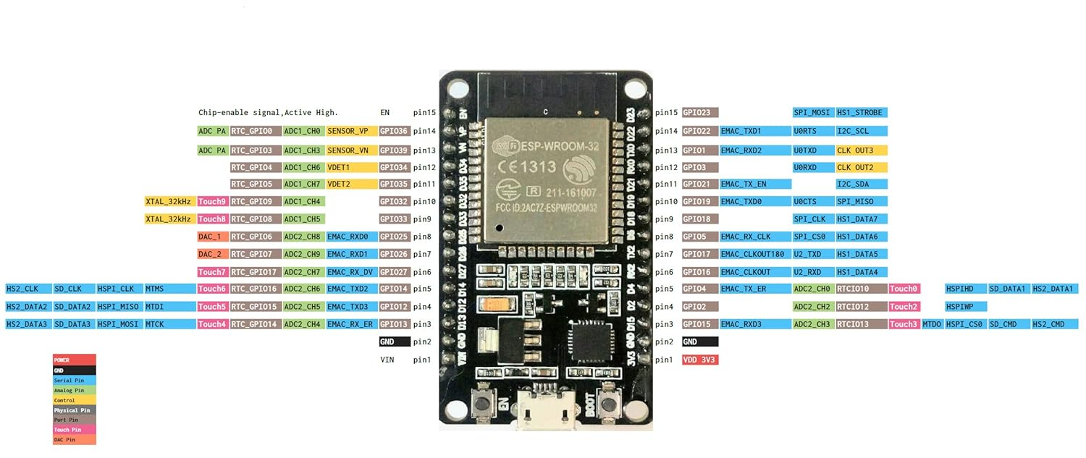

Fig.no . ESP32 Microcontroller

## Relay Module 4 channel

This is a 5V 4-Channel Relay interface board, be able to control various appliances and other equipment with large current. It can be controlled directly by Microcontroller (for Arduino, 8051, AVR, PIC, DSP, ARM, ARM, MSP430, TTL logic).

**Features:**

* 5V 4-Channel Relay interface board and each one needs 15-20mA Driver Current.
* Equipped with high-current relay, AC250V 10A; DC30V 10A.
* Standard interface that can be controlled directly by microcontroller (for Arduino, 8051, AVR, PIC, DSP, ARM, ARM, MSP430, TTL logic).
* Indication LED’s for Relay output status.

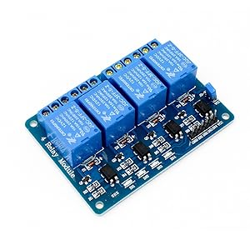

Fig.no 4 Channel Relay Module

## Switches

The switch is rated to 3A at 250VAC and 6A at 125VAC. Wiring these switches is easy; there are two contacts in this Single Pole, Single Throw (SPST) switch, meaning it works as a simple on/off. Wires can be attached via solder.

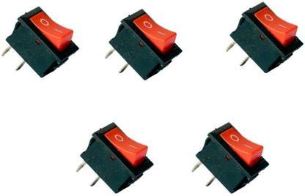

Fig.no Manual Switches

## Buttons

* IP is basically used in the fields of electronic products household appliances and more.
* Precision mechanism design s acute operation and long service life
* Material plastic metal electric parts
* Colour black silver tone

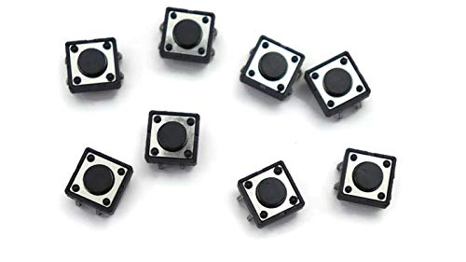

Fig.no Buttons

## LED Lights

Decorative Bulbs Enhance Your Home Atmosphere Philips Led Light Bulbs Provide A Beautiful, Warm White Light, An Exceptionally Long Life, And Immediate, Significant Energy Savings. With A Pure Design, This Bulb Is The Perfect Replacement For Your Cfl Lamps And Clear Incandescent Bulbs. Durability. Lifetime Of Lamp: 15000 Hour(S). Lumen Maintenance Factor: 0.5. Average Life (At 2.7 Hrs/Day): 15.2 Year(S). Number Of Switch Cycles: 50000.

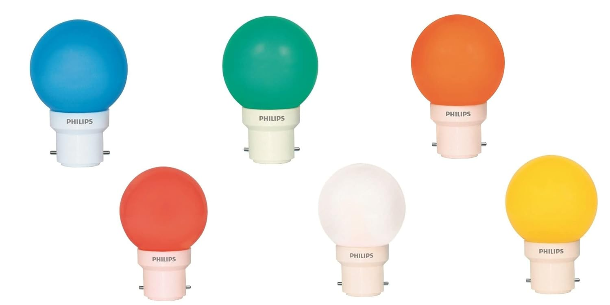

Fig.no LED Bulbs

## Bulb Holders

Current Rating: - 2 Amperes Voltage Rating: - 220-240 Volts, Not compatible for any rating beyond 2A, High Grade Polycarbonate with Heavy Brass Parts.

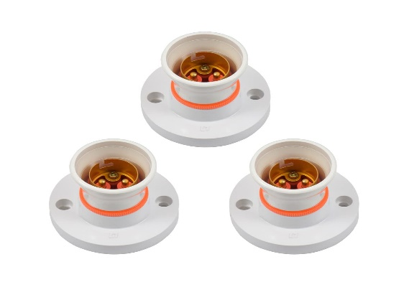

Fig.no Bulb Holder

## ESP Rainmaker

"ESP RainMaker" is a framework developed by Espressif Systems, the manufacturer of the ESP8266 and ESP32 microcontrollers. ESP RainMaker is designed to simplify the development of Internet of Things (IoT) projects on ESP8266 and ESP32 platforms by providing a set of APIs and tools for device provisioning, control, and monitoring.

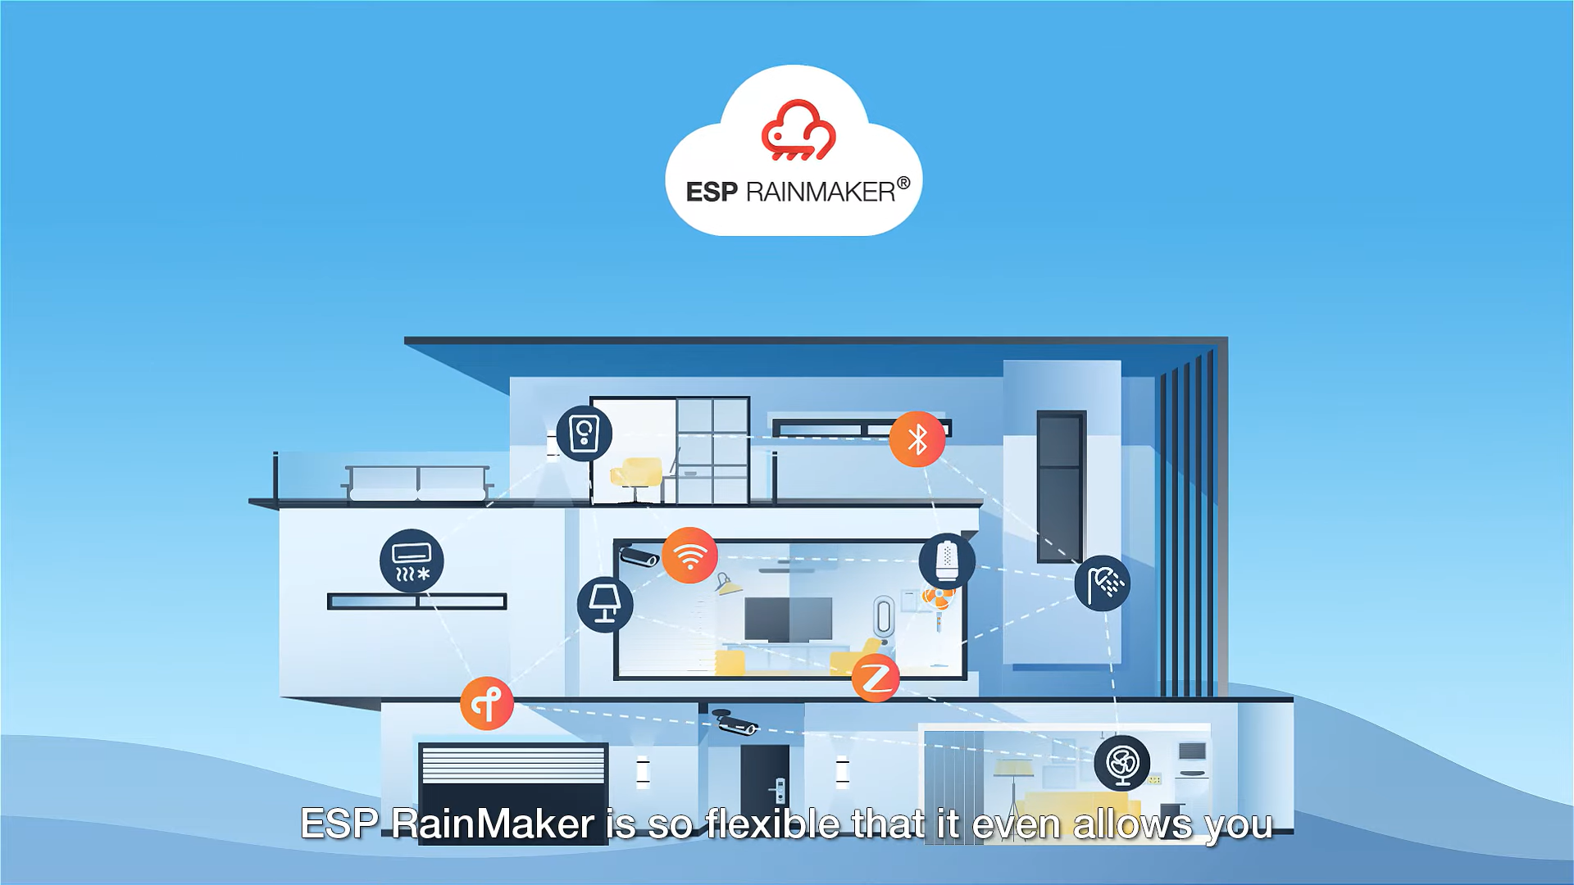

Fig.no ESP Rainmaker

Here are some key features and aspects of ESP RainMaker

1. Device Provisioning

ESP RainMaker facilitates the secure provisioning of ESP8266 and ESP32 devices on Wi-Fi networks. It provides a mechanism for devices to join a network without manual configuration.

1. Cloud Connectivity

The framework enables devices to connect to cloud services, allowing for remote monitoring and control. This can include features such as over-the-air (OTA) updates, device status reporting, and more.

1. Mobile Application Integration

ESP RainMaker often comes with a mobile application that allows users to easily set up and manage their ESP8266 or ESP32 devices. This application typically provides a user-friendly interface for controlling and monitoring connected devices.

1. Security

Security is a crucial aspect of any IoT framework. ESP RainMaker includes mechanisms for secure communication between devices and the cloud, as well as for device provisioning.

1. Device Representation

Devices connected through ESP RainMaker often have a standardized representation or description, making it easier for users to understand and interact with them. This representation may include information about device capabilities, status, and supported actions.

1. APIs and Libraries

Developers working with ESP RainMaker can leverage its APIs and libraries to integrate the framework into their projects. This can expedite the development process by providing pre-built components for common IoT functionalities.

1. Flexibility

ESP RainMaker is designed to be flexible and can be adapted for various IoT applications. It allows developers to focus on their specific use case while providing a robust foundation for connectivity and device management.

1. ESP Rainmaker User Interface for app.

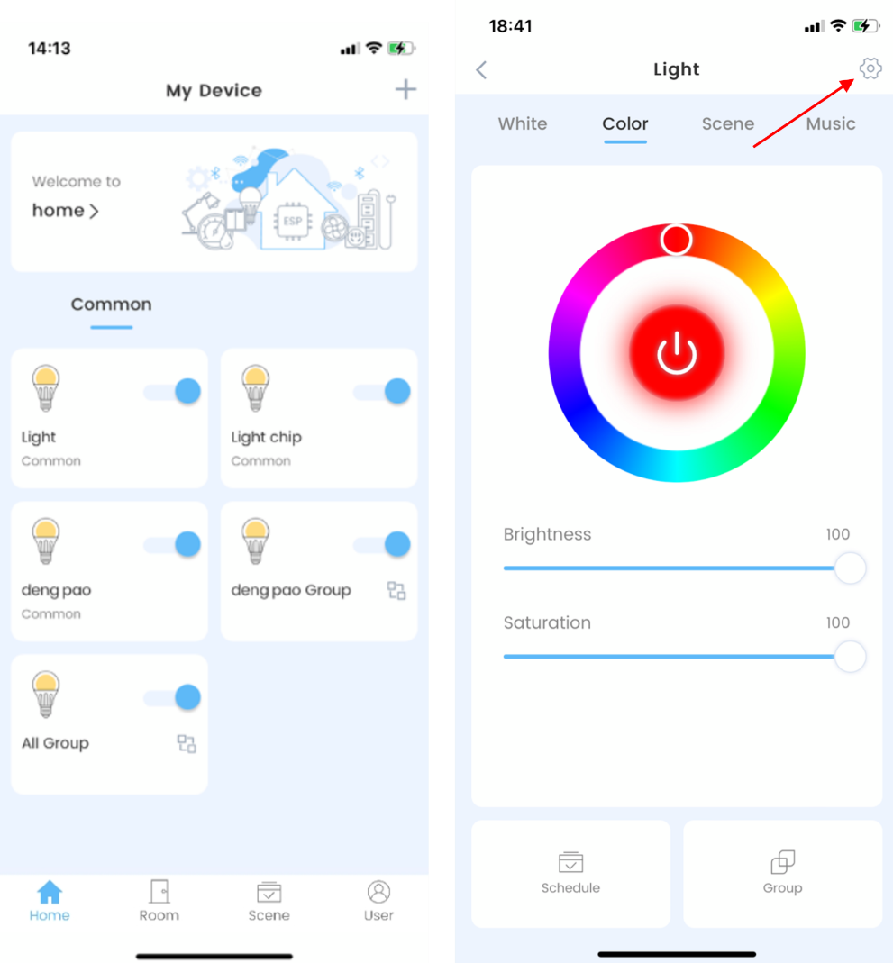

Fig.no ESP Rainmaker user inter face for app

1. ESP Rainmaker Dashboard for web.

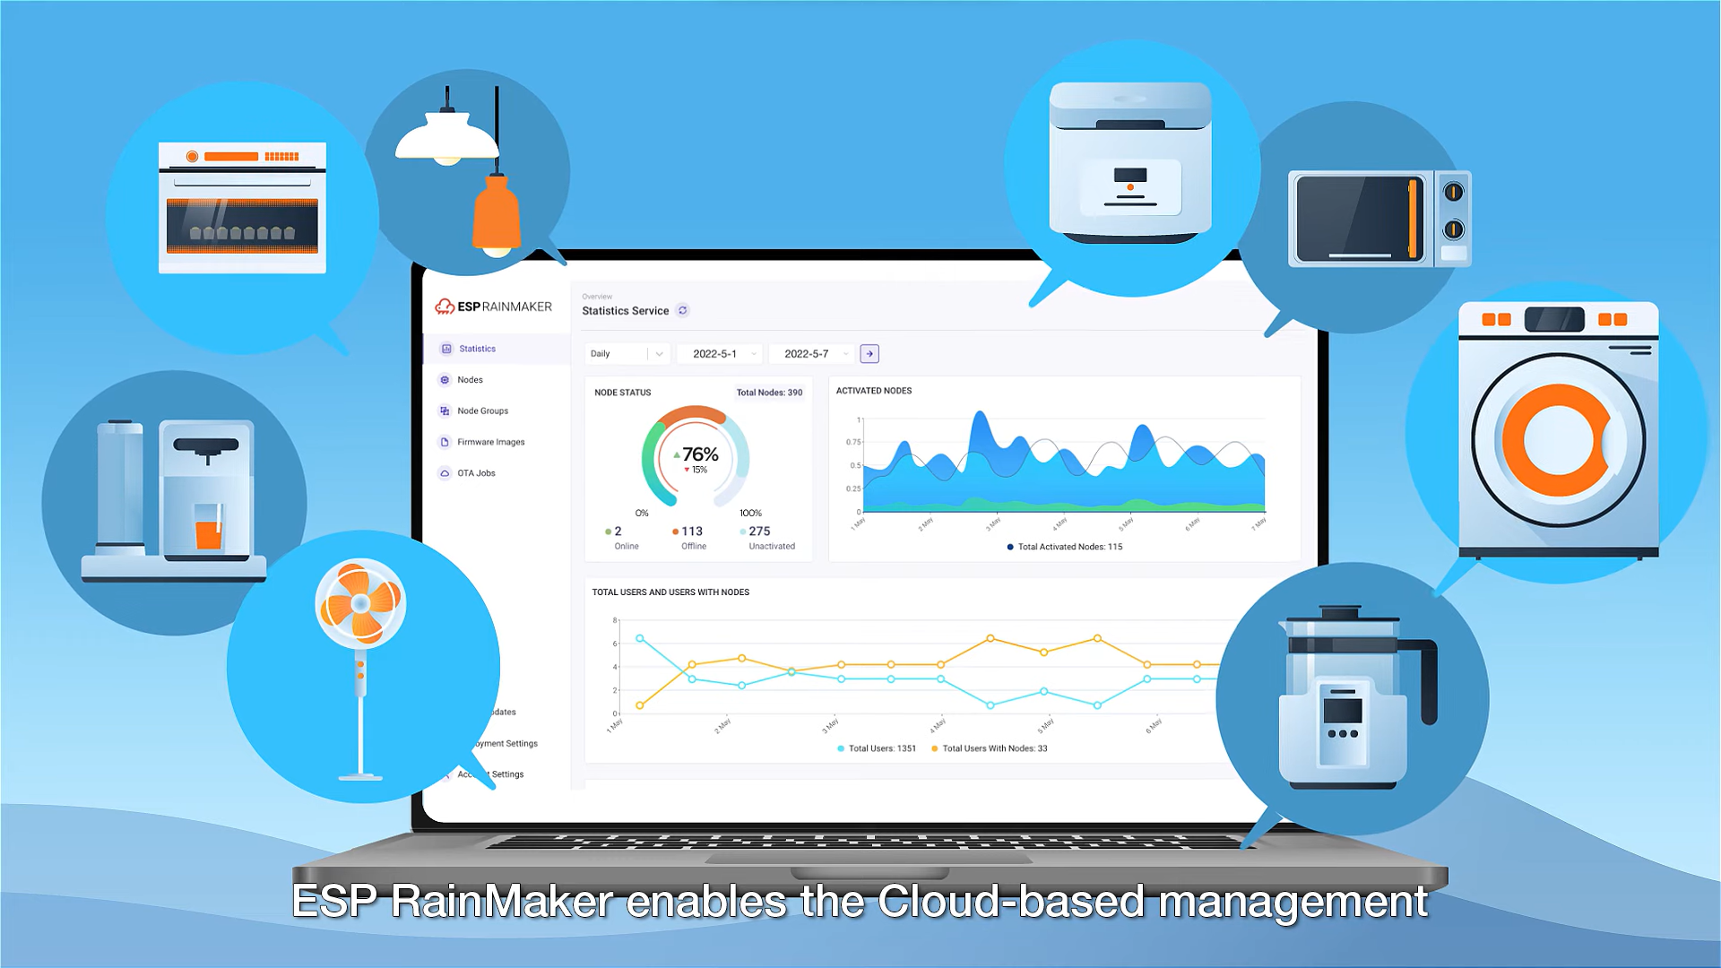

Fig.no ESP Rainmaker Dashboard for web

# Circuit for ESP32 Control 4 Relays

* For this circuit, I have used **D23, D22, D21 & D19** GPIO to control the 4-channel relay module.
* And the GPIO **D13, D12, D14 & D27** are connected with switches to control the relay module manually.
* The board LED connected with the **D2** pin will act as the WiFi indicator.
* If you want to use pushbuttons for manual control, then just connect pushbuttons instead of switches across the GPIO pins and GND.
* I have used the **INPUT_PULLUP** function in Arduino IDE instead of using the pull-up resistors with each push button.
* As per the source code, when the control pins of the relay module receive a **LOW**signal the relay will **turn on** and the relay will **turn off**for the **HIGH** signal in the control pin.
* I have used a 5V 5Amp mobile charger to supply the circuit.

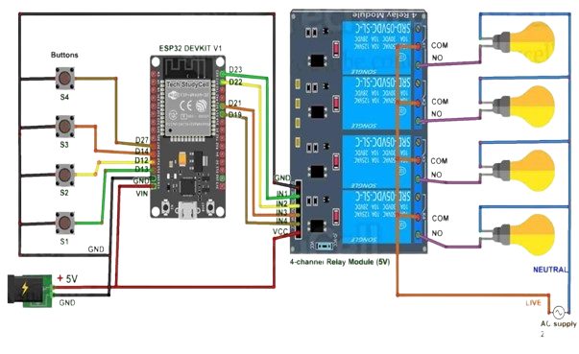

Fig.no Circuit diagram of ESP32 With Relay module

# Program ESP32 With Arduino IDE

## Code for Switched (Latched)

/**********************************************************************************

 *  TITLE: ESP RainMaker + Manual Switch control 4 Relays using ESP32 (Real time feedback + no WiFi control)

 *  Preferences--> Aditional boards Manager URLs :

 *  http://arduino.esp8266.com/stable/package_esp8266com_index.json,https://raw.githubusercontent.com/espressif/arduino-esp32/gh-pages/package_esp32_index.json

 *

 *  Download Board ESP32 (2.0.3) :

 *

 *  Download the libraries :

 *  N/A

 **********************************************************************************/

#include "RMaker.h"

#include "WiFi.h"

#include "WiFiProv.h"

const char *service_name = "PROV_12345";

const char *pop = "1234567";

// define the Device Names

char deviceName_1[] = "Switch1";

char deviceName_2[] = "Switch2";

char deviceName_3[] = "Switch3";

char deviceName_4[] = "Switch4";

// define the GPIO connected with Relays and switches

static uint8_t RelayPin1 = 23;  //D23

static uint8_t RelayPin2 = 22;  //D22

static uint8_t RelayPin3 = 21;  //D21

static uint8_t RelayPin4 = 19;  //D19

static uint8_t SwitchPin1 = 13;  //D13

static uint8_t SwitchPin2 = 12;  //D12

static uint8_t SwitchPin3 = 14;  //D14

static uint8_t SwitchPin4 = 27;  //D27

static uint8_t wifiLed    = 2;   //D2

static uint8_t gpio_reset = 0;

/* Variable for reading pin status*/

// Relay State

bool toggleState_1 = LOW; //Define integer to remember the toggle state for relay 1

bool toggleState_2 = LOW; //Define integer to remember the toggle state for relay 2

bool toggleState_3 = LOW; //Define integer to remember the toggle state for relay 3

bool toggleState_4 = LOW; //Define integer to remember the toggle state for relay 4

// Switch State

bool SwitchState_1 = LOW;

bool SwitchState_2 = LOW;

bool SwitchState_3 = LOW;

bool SwitchState_4 = LOW;

//The framework provides some standard device types like switch, lightbulb, fan, temperature sensor.

static Switch my_switch1(deviceName_1, &RelayPin1);

static Switch my_switch2(deviceName_2, &RelayPin2);

static Switch my_switch3(deviceName_3, &RelayPin3);

static Switch my_switch4(deviceName_4, &RelayPin4);

void sysProvEvent(arduino_event_t *sys_event)

{

    switch (sys_event->event_id) {

        case ARDUINO_EVENT_PROV_START:

#if CONFIG_IDF_TARGET_ESP32

        Serial.printf("\nProvisioning Started with name \"%s\" and PoP \"%s\" on BLE\n", service_name, pop);

        printQR(service_name, pop, "ble");

#else

        Serial.printf("\nProvisioning Started with name \"%s\" and PoP \"%s\" on SoftAP\n", service_name, pop);

        printQR(service_name, pop, "softap");

#endif

        break;

        case ARDUINO_EVENT_WIFI_STA_CONNECTED:

        Serial.printf("\nConnected to Wi-Fi!\n");

        digitalWrite(wifiLed, true);

        break;

    }

}

void write_callback(Device *device, Param *param, const param_val_t val, void *priv_data, write_ctx_t *ctx)

{

    const char *device_name = device->getDeviceName();

    const char *param_name = param->getParamName();

    if(strcmp(device_name, deviceName_1) == 0) {

      Serial.printf("Lightbulb = %s\n", val.val.b? "true" : "false");

      if(strcmp(param_name, "Power") == 0) {

          Serial.printf("Received value = %s for %s - %s\n", val.val.b? "true" : "false", device_name, param_name);

        toggleState_1 = val.val.b;

        (toggleState_1 == false) ? digitalWrite(RelayPin1, HIGH) : digitalWrite(RelayPin1, LOW);

        param->updateAndReport(val);

      }

    } else if(strcmp(device_name, deviceName_2) == 0) {

      Serial.printf("Switch value = %s\n", val.val.b? "true" : "false");

      if(strcmp(param_name, "Power") == 0) {

        Serial.printf("Received value = %s for %s - %s\n", val.val.b? "true" : "false", device_name, param_name);

        toggleState_2 = val.val.b;

        (toggleState_2 == false) ? digitalWrite(RelayPin2, HIGH) : digitalWrite(RelayPin2, LOW);

        param->updateAndReport(val);

      }

    } else if(strcmp(device_name, deviceName_3) == 0) {

      Serial.printf("Switch value = %s\n", val.val.b? "true" : "false");

      if(strcmp(param_name, "Power") == 0) {

        Serial.printf("Received value = %s for %s - %s\n", val.val.b? "true" : "false", device_name, param_name);

        toggleState_3 = val.val.b;

        (toggleState_3 == false) ? digitalWrite(RelayPin3, HIGH) : digitalWrite(RelayPin3, LOW);

        param->updateAndReport(val);

      }

    } else if(strcmp(device_name, deviceName_4) == 0) {

      Serial.printf("Switch value = %s\n", val.val.b? "true" : "false");

      if(strcmp(param_name, "Power") == 0) {

        Serial.printf("Received value = %s for %s - %s\n", val.val.b? "true" : "false", device_name, param_name);

        toggleState_4 = val.val.b;

        (toggleState_4 == false) ? digitalWrite(RelayPin4, HIGH) : digitalWrite(RelayPin4, LOW);

        param->updateAndReport(val);

      }

    }

}

void manual_control()

{

  if (digitalRead(SwitchPin1) == LOW && SwitchState_1 == LOW) {

    digitalWrite(RelayPin1, LOW);

    toggleState_1 = 1;

    SwitchState_1 = HIGH;

    my_switch1.updateAndReportParam(ESP_RMAKER_DEF_POWER_NAME, toggleState_1);

    Serial.println("Switch-1 on");

  }

  if (digitalRead(SwitchPin1) == HIGH && SwitchState_1 == HIGH) {

    digitalWrite(RelayPin1, HIGH);

    toggleState_1 = 0;

    SwitchState_1 = LOW;

    my_switch1.updateAndReportParam(ESP_RMAKER_DEF_POWER_NAME, toggleState_1);

    Serial.println("Switch-1 off");

  }

  if (digitalRead(SwitchPin2) == LOW && SwitchState_2 == LOW) {

    digitalWrite(RelayPin2, LOW);

    toggleState_2 = 1;

    SwitchState_2 = HIGH;

    my_switch2.updateAndReportParam(ESP_RMAKER_DEF_POWER_NAME, toggleState_2);

    Serial.println("Switch-2 on");

  }

  if (digitalRead(SwitchPin2) == HIGH && SwitchState_2 == HIGH) {

    digitalWrite(RelayPin2, HIGH);

    toggleState_2 = 0;

    SwitchState_2 = LOW;

    my_switch2.updateAndReportParam(ESP_RMAKER_DEF_POWER_NAME, toggleState_2);

    Serial.println("Switch-2 off");

  }

  if (digitalRead(SwitchPin3) == LOW && SwitchState_3 == LOW) {

    digitalWrite(RelayPin3, LOW);

    toggleState_3 = 1;

    SwitchState_3 = HIGH;

    my_switch3.updateAndReportParam(ESP_RMAKER_DEF_POWER_NAME, toggleState_3);

    Serial.println("Switch-3 on");

  }

  if (digitalRead(SwitchPin3) == HIGH && SwitchState_3 == HIGH) {

    digitalWrite(RelayPin3, HIGH);

    toggleState_3 = 0;

    SwitchState_3 = LOW;

    my_switch3.updateAndReportParam(ESP_RMAKER_DEF_POWER_NAME, toggleState_3);

    Serial.println("Switch-3 off");

  }

  if (digitalRead(SwitchPin4) == LOW && SwitchState_4 == LOW) {

    digitalWrite(RelayPin4, LOW);

    toggleState_4 = 1;

    SwitchState_4 = HIGH;

    my_switch4.updateAndReportParam(ESP_RMAKER_DEF_POWER_NAME, toggleState_4);

    Serial.println("Switch-4 on");

  }

  if (digitalRead(SwitchPin4) == HIGH && SwitchState_4 == HIGH) {

    digitalWrite(RelayPin4, HIGH);

    toggleState_4 = 0;

    SwitchState_4 = LOW;

    my_switch4.updateAndReportParam(ESP_RMAKER_DEF_POWER_NAME, toggleState_4);

    Serial.println("Switch-4 off");

  }

}

void setup()

{

    uint32_t chipId = 0;

    Serial.begin(115200);

    // Set the Relays GPIOs as output mode

    pinMode(RelayPin1, OUTPUT);

    pinMode(RelayPin2, OUTPUT);

    pinMode(RelayPin3, OUTPUT);

    pinMode(RelayPin4, OUTPUT);

    pinMode(wifiLed, OUTPUT);

    // Configure the input GPIOs

    pinMode(SwitchPin1, INPUT_PULLUP);

    pinMode(SwitchPin2, INPUT_PULLUP);

    pinMode(SwitchPin3, INPUT_PULLUP);

    pinMode(SwitchPin4, INPUT_PULLUP);

    pinMode(gpio_reset, INPUT);

    // Write to the GPIOs the default state on booting

    digitalWrite(RelayPin1, !toggleState_1);

    digitalWrite(RelayPin2, !toggleState_2);

    digitalWrite(RelayPin3, !toggleState_3);

    digitalWrite(RelayPin4, !toggleState_4);

    digitalWrite(wifiLed, LOW);

    Node my_node;

    my_node = RMaker.initNode("ESP32_Relay_4");

    //Standard switch device

    my_switch1.addCb(write_callback);

    my_switch2.addCb(write_callback);

    my_switch3.addCb(write_callback);

    my_switch4.addCb(write_callback);

    //Add switch device to the node

    my_node.addDevice(my_switch1);

    my_node.addDevice(my_switch2);

    my_node.addDevice(my_switch3);

    my_node.addDevice(my_switch4);

    //This is optional

    RMaker.enableOTA(OTA_USING_PARAMS);

    //If you want to enable scheduling, set time zone for your region using setTimeZone().

    //The list of available values are provided here https://rainmaker.espressif.com/docs/time-service.html

    // RMaker.setTimeZone("Asia/Shanghai");

    // Alternatively, enable the Timezone service and let the phone apps set the appropriate timezone

    RMaker.enableTZService();

    RMaker.enableSchedule();

    //Service Name

    for(int i=0; i<17; i=i+8) {

      chipId |= ((ESP.getEfuseMac() >> (40 - i)) & 0xff) << i;

    }

    Serial.printf("\nChip ID:  %d Service Name: %s\n", chipId, service_name);

    Serial.printf("\nStarting ESP-RainMaker\n");

    RMaker.start();

    WiFi.onEvent(sysProvEvent);

#if CONFIG_IDF_TARGET_ESP32

    WiFiProv.beginProvision(WIFI_PROV_SCHEME_BLE, WIFI_PROV_SCHEME_HANDLER_FREE_BTDM, WIFI_PROV_SECURITY_1, pop, service_name);

#else

    WiFiProv.beginProvision(WIFI_PROV_SCHEME_SOFTAP, WIFI_PROV_SCHEME_HANDLER_NONE, WIFI_PROV_SECURITY_1, pop, service_name);

#endif

    my_switch1.updateAndReportParam(ESP_RMAKER_DEF_POWER_NAME, false);

    my_switch2.updateAndReportParam(ESP_RMAKER_DEF_POWER_NAME, false);

    my_switch3.updateAndReportParam(ESP_RMAKER_DEF_POWER_NAME, false);

    my_switch4.updateAndReportParam(ESP_RMAKER_DEF_POWER_NAME, false);

}

void loop()

{

    // Read GPIO0 (external button to reset device

    if(digitalRead(gpio_reset) == LOW) { //Push button pressed

        Serial.printf("Reset Button Pressed!\n");

        // Key debounce handling

        delay(100);

        int startTime = millis();

        while(digitalRead(gpio_reset) == LOW) delay(50);

        int endTime = millis();

        if ((endTime - startTime) > 10000) {

          // If key pressed for more than 10secs, reset all

          Serial.printf("Reset to factory.\n");

          RMakerFactoryReset(2);

        } else if ((endTime - startTime) > 3000) {

          Serial.printf("Reset Wi-Fi.\n");

          // If key pressed for more than 3secs, but less than 10, reset Wi-Fi

          RMakerWiFiReset(2);

        }

    }

    delay(100);

    if (WiFi.status() != WL_CONNECTED)

    {

      //Serial.println("WiFi Not Connected");

      digitalWrite(wifiLed, false);

    }

    else

    {

      //Serial.println("WiFi Connected");

      digitalWrite(wifiLed, true);

    }

    manual_control();

}

## Code for Buttons (Momentary)

/**********************************************************************************

 *  TITLE: ESP RainMaker + Manual Button control 4 Relays using ESP32 (Real time feedback + no WiFi control)

 *  by Tech StudyCell

 *  Preferences--> Aditional boards Manager URLs :

 *  http://arduino.esp8266.com/stable/package_esp8266com_index.json,https://raw.githubusercontent.com/espressif/arduino-esp32/gh-pages/package_esp32_index.json

 *

 *  Download Board ESP32 (2.0.3):

 *

 *  Download the libraries

 *  AceButton Library: https://github.com/bxparks/AceButton

 **********************************************************************************/

#include "RMaker.h"

#include "WiFi.h"

#include "WiFiProv.h"

#include <AceButton.h>

using namespace ace_button;

const char *service_name = "PROV_12345";

const char *pop = "1234567";

// define the Device Names

char deviceName_1[] = "Switch1";

char deviceName_2[] = "Switch2";

char deviceName_3[] = "Switch3";

char deviceName_4[] = "Switch4";

// define the GPIO connected with Relays and switches

static uint8_t RelayPin1 = 23;  //D23

static uint8_t RelayPin2 = 22;  //D22

static uint8_t RelayPin3 = 21;  //D21

static uint8_t RelayPin4 = 19;  //D19

static uint8_t SwitchPin1 = 13;  //D13

static uint8_t SwitchPin2 = 12;  //D12

static uint8_t SwitchPin3 = 14;  //D14

static uint8_t SwitchPin4 = 27;  //D27

static uint8_t wifiLed    = 2;   //D2

static uint8_t gpio_reset = 0;

/* Variable for reading pin status*/

bool toggleState_1 = LOW; //Define integer to remember the toggle state for relay 1

bool toggleState_2 = LOW; //Define integer to remember the toggle state for relay 2

bool toggleState_3 = LOW; //Define integer to remember the toggle state for relay 3

bool toggleState_4 = LOW; //Define integer to remember the toggle state for relay 4

ButtonConfig config1;

AceButton button1(&config1);

ButtonConfig config2;

AceButton button2(&config2);

ButtonConfig config3;

AceButton button3(&config3);

ButtonConfig config4;

AceButton button4(&config4);

void handleEvent1(AceButton*, uint8_t, uint8_t);

void handleEvent2(AceButton*, uint8_t, uint8_t);

void handleEvent3(AceButton*, uint8_t, uint8_t);

void handleEvent4(AceButton*, uint8_t, uint8_t);

//The framework provides some standard device types like switch, lightbulb, fan, temperature sensor.

static Switch my_switch1(deviceName_1, &RelayPin1);

static Switch my_switch2(deviceName_2, &RelayPin2);

static Switch my_switch3(deviceName_3, &RelayPin3);

static Switch my_switch4(deviceName_4, &RelayPin4);

void sysProvEvent(arduino_event_t *sys_event)

{

    switch (sys_event->event_id) {

        case ARDUINO_EVENT_PROV_START:

#if CONFIG_IDF_TARGET_ESP32

        Serial.printf("\nProvisioning Started with name \"%s\" and PoP \"%s\" on BLE\n", service_name, pop);

        printQR(service_name, pop, "ble");

#else

        Serial.printf("\nProvisioning Started with name \"%s\" and PoP \"%s\" on SoftAP\n", service_name, pop);

        printQR(service_name, pop, "softap");

#endif

        break;

        case ARDUINO_EVENT_WIFI_STA_CONNECTED:

        Serial.printf("\nConnected to Wi-Fi!\n");

        digitalWrite(wifiLed, true);

        break;

    }

}

void write_callback(Device *device, Param *param, const param_val_t val, void *priv_data, write_ctx_t *ctx)

{

    const char *device_name = device->getDeviceName();

    const char *param_name = param->getParamName();

    if(strcmp(device_name, deviceName_1) == 0) {

      Serial.printf("Lightbulb = %s\n", val.val.b? "true" : "false");

      if(strcmp(param_name, "Power") == 0) {

          Serial.printf("Received value = %s for %s - %s\n", val.val.b? "true" : "false", device_name, param_name);

        toggleState_1 = val.val.b;

        (toggleState_1 == false) ? digitalWrite(RelayPin1, HIGH) : digitalWrite(RelayPin1, LOW);

        param->updateAndReport(val);

      }

    } else if(strcmp(device_name, deviceName_2) == 0) {

      Serial.printf("Switch value = %s\n", val.val.b? "true" : "false");

      if(strcmp(param_name, "Power") == 0) {

        Serial.printf("Received value = %s for %s - %s\n", val.val.b? "true" : "false", device_name, param_name);

        toggleState_2 = val.val.b;

        (toggleState_2 == false) ? digitalWrite(RelayPin2, HIGH) : digitalWrite(RelayPin2, LOW);

        param->updateAndReport(val);

      }

    } else if(strcmp(device_name, deviceName_3) == 0) {

      Serial.printf("Switch value = %s\n", val.val.b? "true" : "false");

      if(strcmp(param_name, "Power") == 0) {

        Serial.printf("Received value = %s for %s - %s\n", val.val.b? "true" : "false", device_name, param_name);

        toggleState_3 = val.val.b;

        (toggleState_3 == false) ? digitalWrite(RelayPin3, HIGH) : digitalWrite(RelayPin3, LOW);

        param->updateAndReport(val);

      }

    } else if(strcmp(device_name, deviceName_4) == 0) {

      Serial.printf("Switch value = %s\n", val.val.b? "true" : "false");

      if(strcmp(param_name, "Power") == 0) {

        Serial.printf("Received value = %s for %s - %s\n", val.val.b? "true" : "false", device_name, param_name);

        toggleState_4 = val.val.b;

        (toggleState_4 == false) ? digitalWrite(RelayPin4, HIGH) : digitalWrite(RelayPin4, LOW);

        param->updateAndReport(val);

      }

    }

}

void setup()

{

    uint32_t chipId = 0;

    Serial.begin(115200);

    // Set the Relays GPIOs as output mode

    pinMode(RelayPin1, OUTPUT);

    pinMode(RelayPin2, OUTPUT);

    pinMode(RelayPin3, OUTPUT);

    pinMode(RelayPin4, OUTPUT);

    pinMode(wifiLed, OUTPUT);

    // Configure the input GPIOs

    pinMode(SwitchPin1, INPUT_PULLUP);

    pinMode(SwitchPin2, INPUT_PULLUP);

    pinMode(SwitchPin3, INPUT_PULLUP);

    pinMode(SwitchPin4, INPUT_PULLUP);

    pinMode(gpio_reset, INPUT);

    // Write to the GPIOs the default state on booting

    digitalWrite(RelayPin1, !toggleState_1);

    digitalWrite(RelayPin2, !toggleState_2);

    digitalWrite(RelayPin3, !toggleState_3);

    digitalWrite(RelayPin4, !toggleState_4);

    digitalWrite(wifiLed, LOW);

    config1.setEventHandler(button1Handler);

    config2.setEventHandler(button2Handler);

    config3.setEventHandler(button3Handler);

    config4.setEventHandler(button4Handler);

    button1.init(SwitchPin1);

    button2.init(SwitchPin2);

    button3.init(SwitchPin3);

    button4.init(SwitchPin4);

    Node my_node;

    my_node = RMaker.initNode("ESP32_Relay_4");

    //Standard switch device

    my_switch1.addCb(write_callback);

    my_switch2.addCb(write_callback);

    my_switch3.addCb(write_callback);

    my_switch4.addCb(write_callback);

    //Add switch device to the node

    my_node.addDevice(my_switch1);

    my_node.addDevice(my_switch2);

    my_node.addDevice(my_switch3);

    my_node.addDevice(my_switch4);

    //This is optional

    RMaker.enableOTA(OTA_USING_PARAMS);

    //If you want to enable scheduling, set time zone for your region using setTimeZone().

    //The list of available values are provided here https://rainmaker.espressif.com/docs/time-service.html

    // RMaker.setTimeZone("Asia/Shanghai");

    // Alternatively, enable the Timezone service and let the phone apps set the appropriate timezone

    RMaker.enableTZService();

    RMaker.enableSchedule();

    //Service Name

    for(int i=0; i<17; i=i+8) {

      chipId |= ((ESP.getEfuseMac() >> (40 - i)) & 0xff) << i;

    }

    Serial.printf("\nChip ID:  %d Service Name: %s\n", chipId, service_name);

    Serial.printf("\nStarting ESP-RainMaker\n");

    RMaker.start();

    WiFi.onEvent(sysProvEvent);

#if CONFIG_IDF_TARGET_ESP32

    WiFiProv.beginProvision(WIFI_PROV_SCHEME_BLE, WIFI_PROV_SCHEME_HANDLER_FREE_BTDM, WIFI_PROV_SECURITY_1, pop, service_name);

#else

    WiFiProv.beginProvision(WIFI_PROV_SCHEME_SOFTAP, WIFI_PROV_SCHEME_HANDLER_NONE, WIFI_PROV_SECURITY_1, pop, service_name);

#endif

    my_switch1.updateAndReportParam(ESP_RMAKER_DEF_POWER_NAME, false);

    my_switch2.updateAndReportParam(ESP_RMAKER_DEF_POWER_NAME, false);

    my_switch3.updateAndReportParam(ESP_RMAKER_DEF_POWER_NAME, false);

    my_switch4.updateAndReportParam(ESP_RMAKER_DEF_POWER_NAME, false);

}

void loop()

{

    // Read GPIO0 (external button to reset device

    if(digitalRead(gpio_reset) == LOW) { //Push button pressed

        Serial.printf("Reset Button Pressed!\n");

        // Key debounce handling

        delay(100);

        int startTime = millis();

        while(digitalRead(gpio_reset) == LOW) delay(50);

        int endTime = millis();

        if ((endTime - startTime) > 10000) {

          // If key pressed for more than 10secs, reset all

          Serial.printf("Reset to factory.\n");

          RMakerFactoryReset(2);

        } else if ((endTime - startTime) > 3000) {

          Serial.printf("Reset Wi-Fi.\n");

          // If key pressed for more than 3secs, but less than 10, reset Wi-Fi

          RMakerWiFiReset(2);

        }

    }

    delay(100);

    if (WiFi.status() != WL_CONNECTED)

    {

      //Serial.println("WiFi Not Connected");

      digitalWrite(wifiLed, false);

    }

    else

    {

      //Serial.println("WiFi Connected");

      digitalWrite(wifiLed, true);

    }

    button1.check();

    button2.check();

    button3.check();

    button4.check();

}

void button1Handler(AceButton* button, uint8_t eventType, uint8_t buttonState) {

  Serial.println("EVENT1");

  switch (eventType) {

    case AceButton::kEventReleased:

      digitalWrite(RelayPin1, toggleState_1);

      toggleState_1 = !toggleState_1;

      my_switch1.updateAndReportParam(ESP_RMAKER_DEF_POWER_NAME, toggleState_1);

      break;

  }

}

void button2Handler(AceButton* button, uint8_t eventType, uint8_t buttonState) {

  Serial.println("EVENT2");

  switch (eventType) {

    case AceButton::kEventReleased:

      digitalWrite(RelayPin2, toggleState_2);

      toggleState_2 = !toggleState_2;

      my_switch2.updateAndReportParam(ESP_RMAKER_DEF_POWER_NAME, toggleState_2);

      break;

  }

}

void button3Handler(AceButton* button, uint8_t eventType, uint8_t buttonState) {

  Serial.println("EVENT3");

  switch (eventType) {

    case AceButton::kEventReleased:

      digitalWrite(RelayPin3, toggleState_3);

      toggleState_3 = !toggleState_3;

      my_switch3.updateAndReportParam(ESP_RMAKER_DEF_POWER_NAME, toggleState_3);

      break;

  }

}

void button4Handler(AceButton* button, uint8_t eventType, uint8_t buttonState) {

  Serial.println("EVENT4");

  switch (eventType) {

    case AceButton::kEventReleased:

      digitalWrite(RelayPin4, toggleState_4);

      toggleState_4 = !toggleState_4;

      my_switch4.updateAndReportParam(ESP_RMAKER_DEF_POWER_NAME, toggleState_4);

      break;

  }

}

## Code for Change Device Name

In the code, if you want you can change the device names. Google and Alexa will identify the devices with these names.

// define the Device Names

char deviceName_1[] = "Switch1";

char deviceName_2[] = "Switch2";

char deviceName_3[] = "Switch3";

char deviceName_4[] = "Switch4";

char deviceName_5[] = "Switch5";

char deviceName_6[] = "Switch6";

char deviceName_7[] = "Switch7";

char deviceName_8[] = "Switch8";

# Working

1. Start by write the code on Arduino IDE for controlling ESP32 Microcontroller.

Download link of Arduino IDE

For Window <https://downloads.arduino.cc/arduino-ide/arduino-ide_2.2.1_Windows_64bit.exe>

For MacOS <https://downloads.arduino.cc/arduino-ide/arduino-ide_2.2.1_macOS_arm64.dmg>

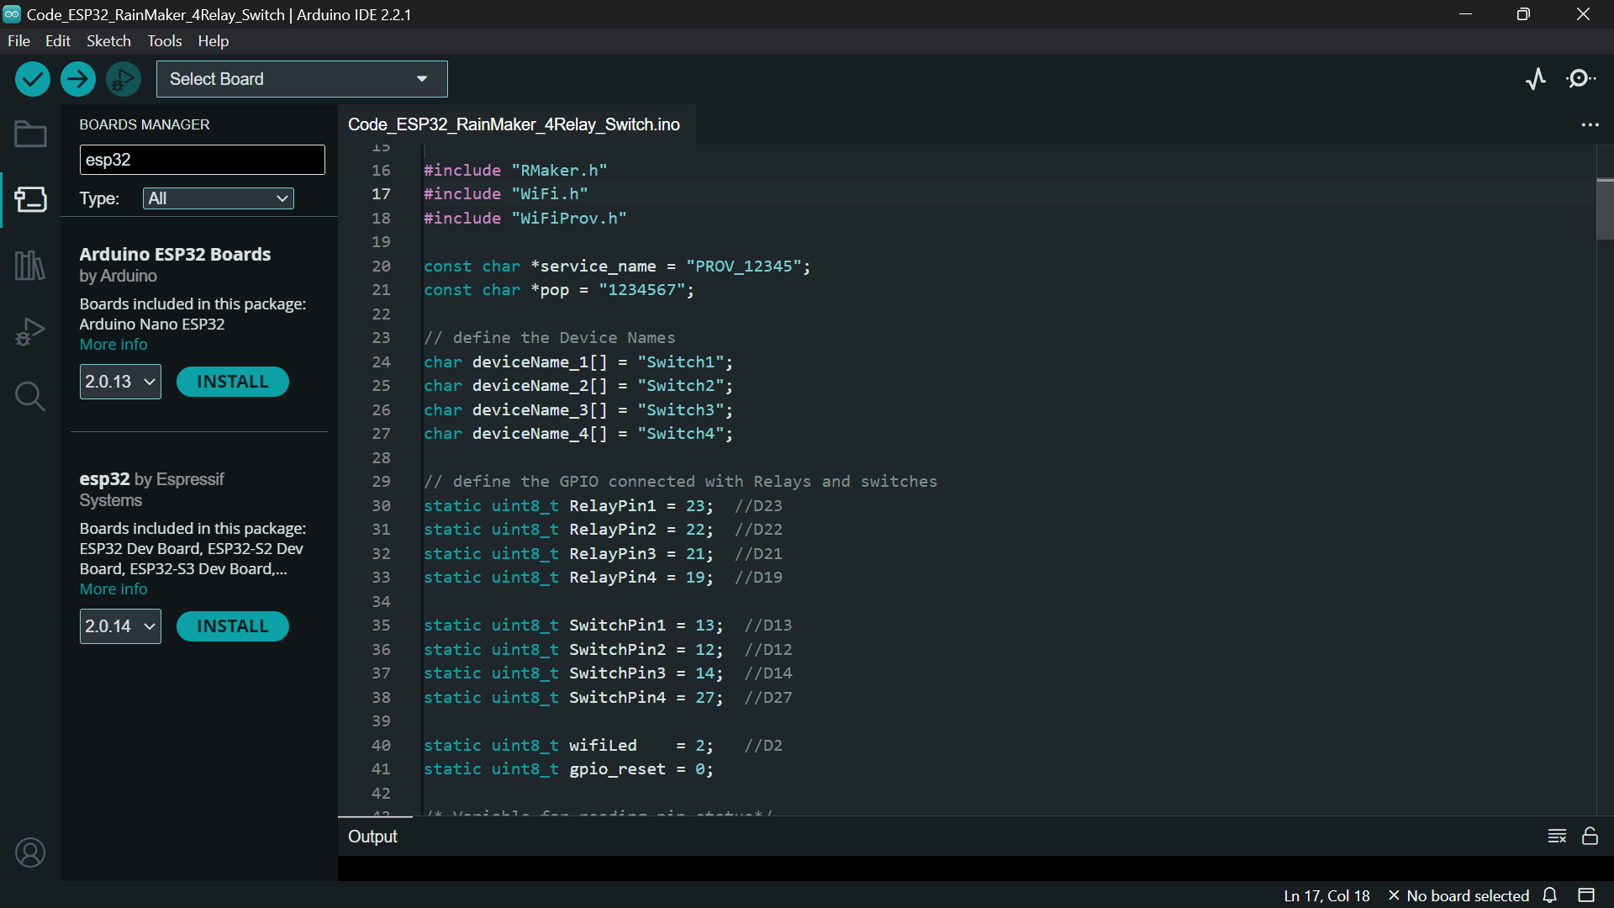

Fig.no Code on Arduino IDE

1. Now compile and upload the code in ESP32.

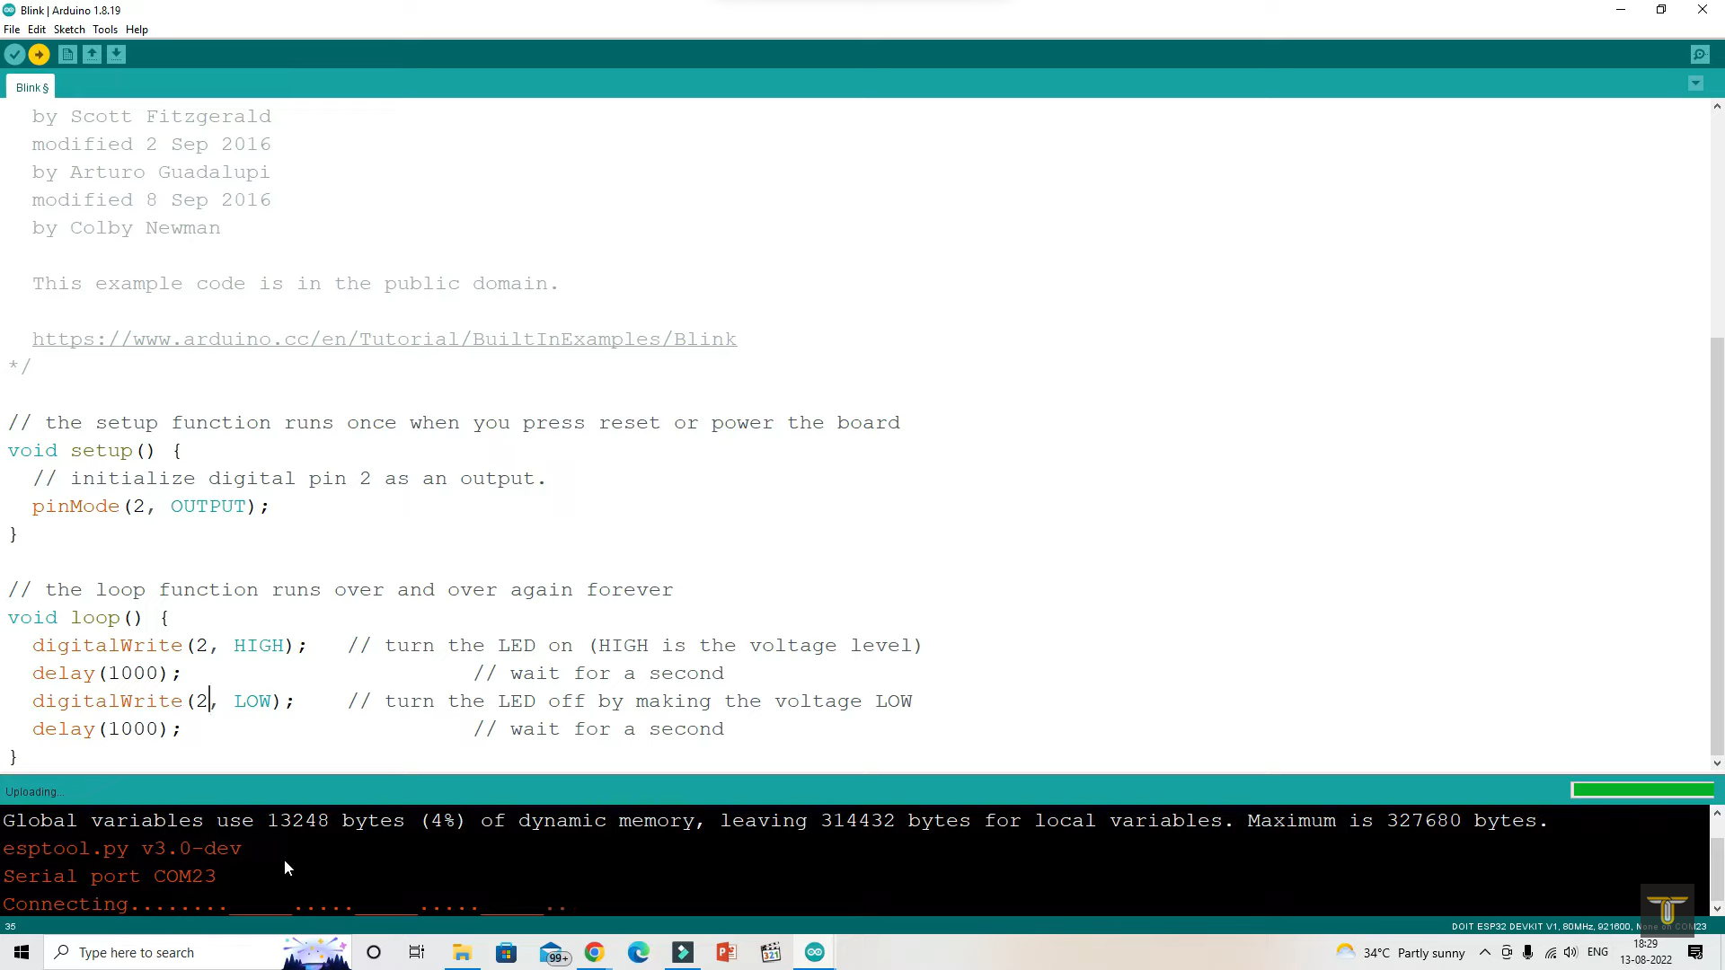

Fig.no Compile and uploading code

1. Now we connect all the components with the help of circuit diagram with ESP32 Microcontroller.

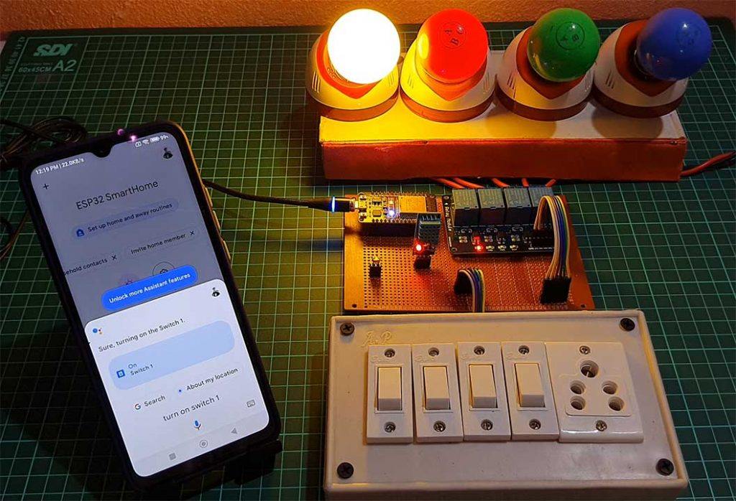

Fig.no Assembled Hardwere

1. After this download the ESP rainmaker app in your mobile phone.

Download link

For android <https://play.google.com/store/search?q=esp+rainmaker&c=apps>

For IOS <https://apps.apple.com/in/app/esp-rainmaker/id1497491540>

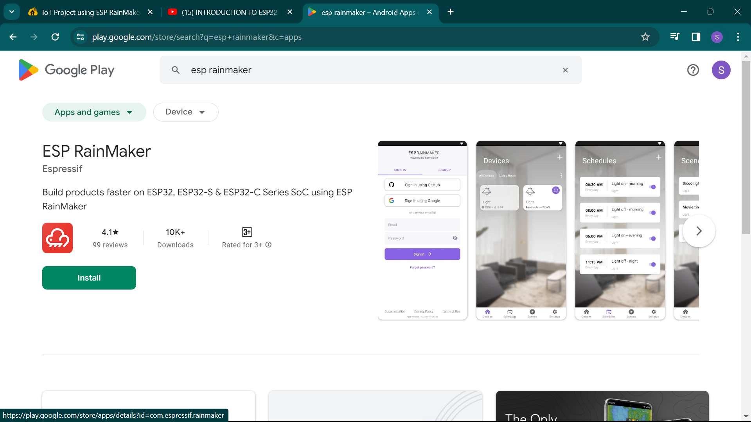 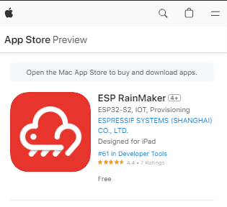

Fig.no ESP android and IOS app

1. Connect this app with ESP 32 microcontroller with the help of QR code Which is generated through Arduino IDE. For this required Wi Fi connectivity between app and ESP32.

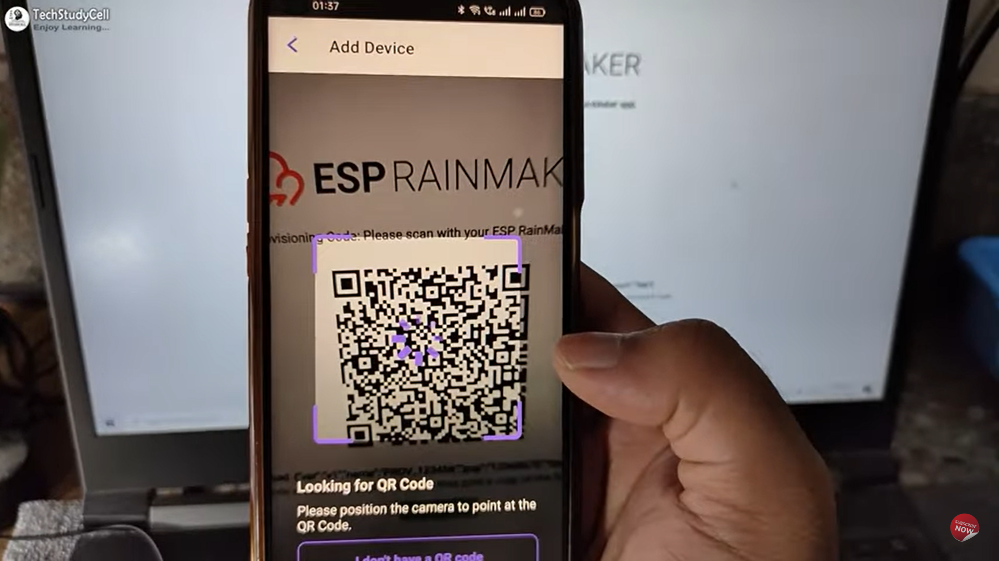

Fig.no Connecting ESP Rainmaker app by QR Code

1. Now we can control our home appliances by using ESP rain Maker app.

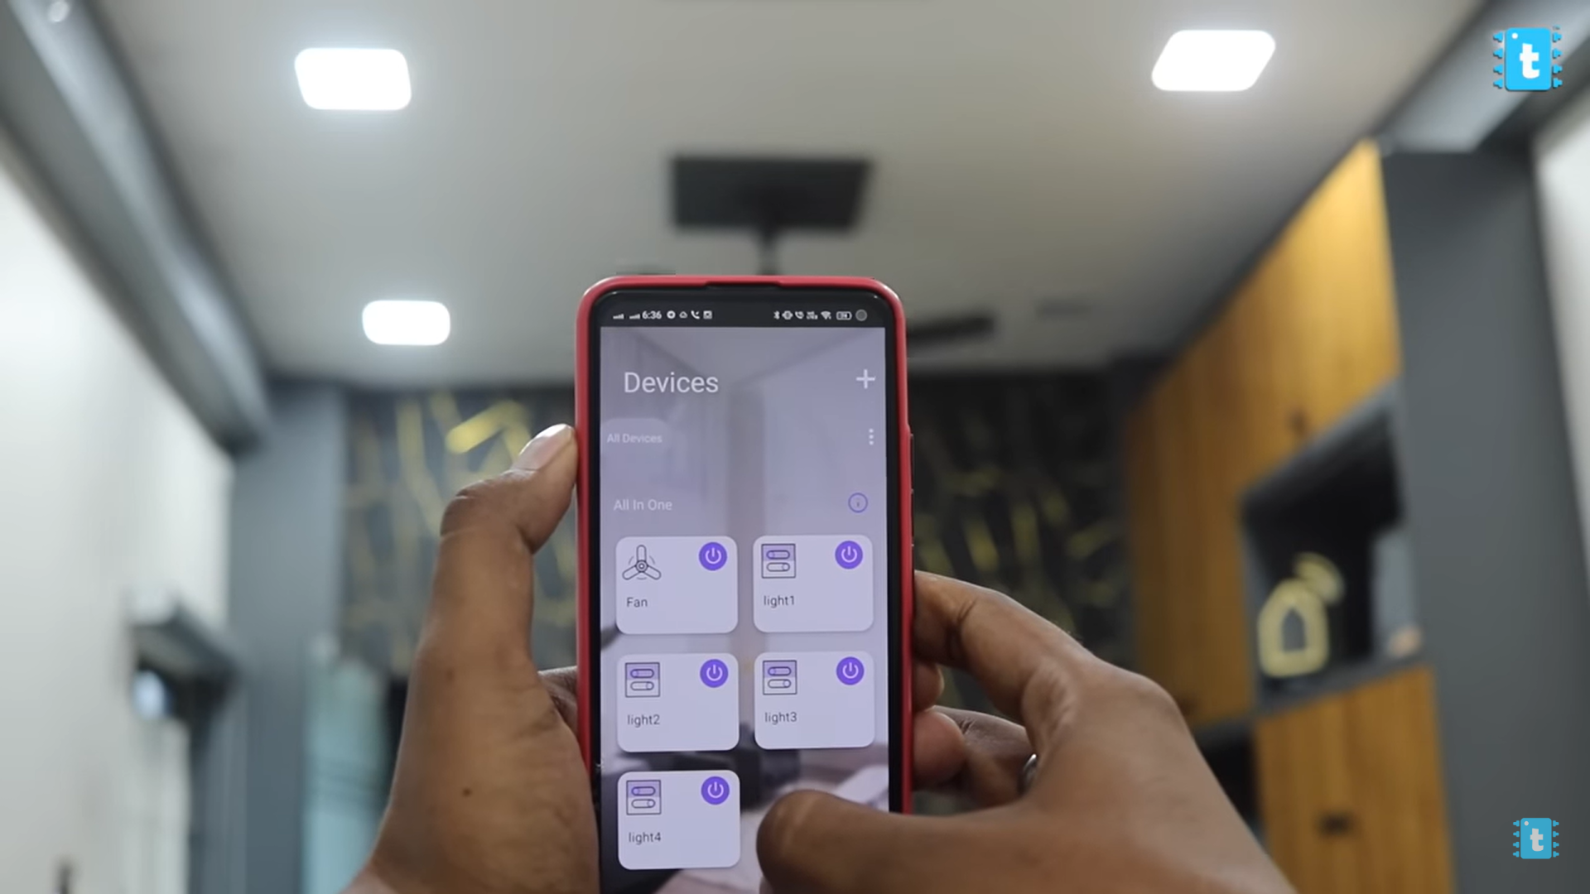

Fig.no Control our home appliances by using ESP rain Maker app

1. Download google home from play store/app store.

Download link

For android <https://play.google.com/store/search?q=google+home&c=apps>

For IOS <https://apps.apple.com/in/app/google-home/id680819774>

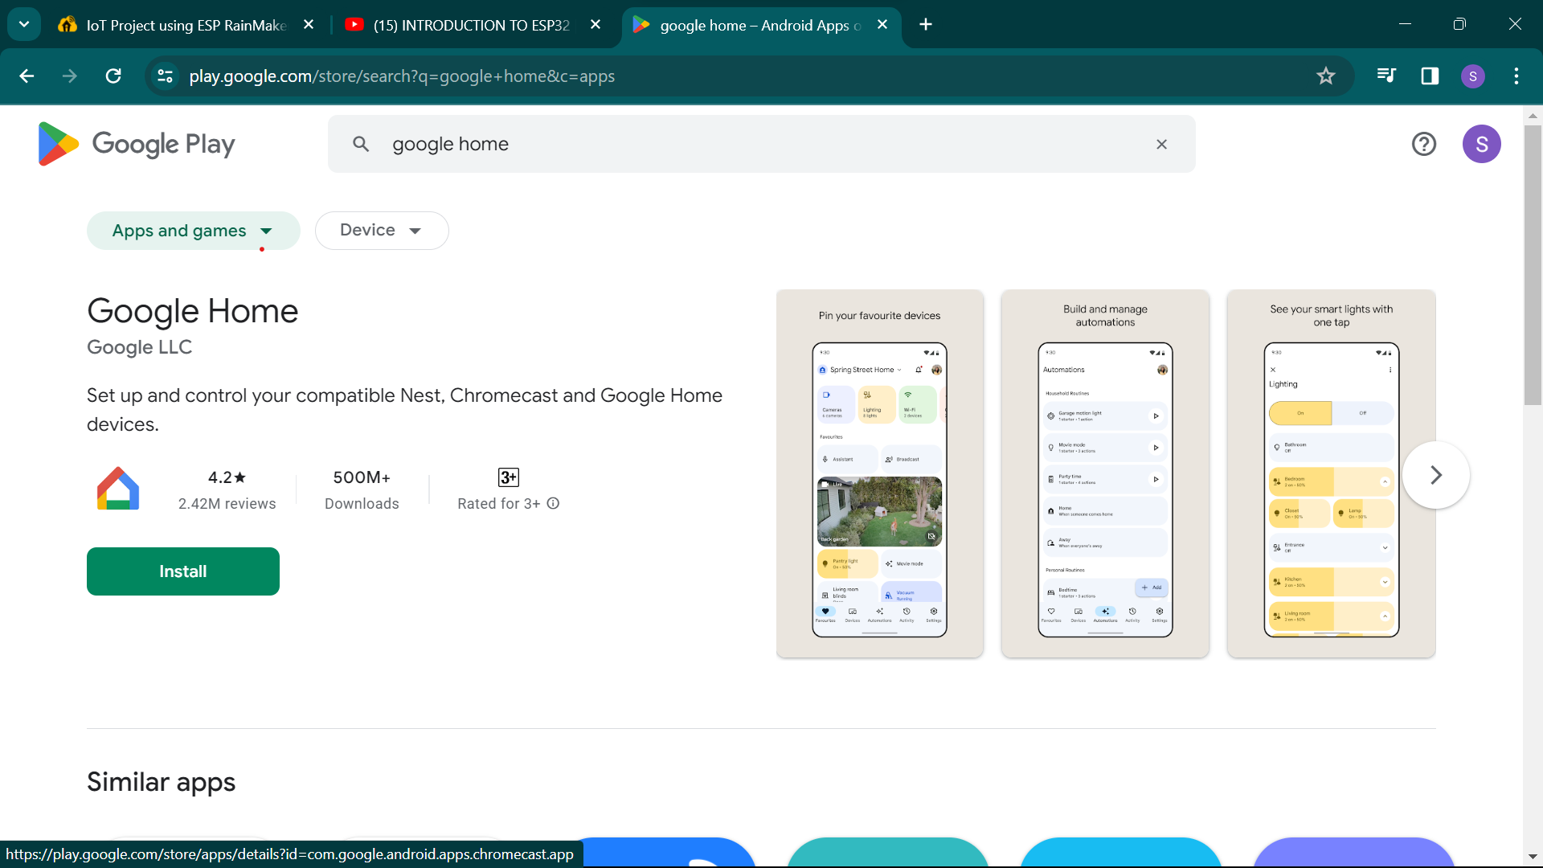 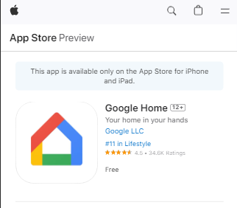

Fig.no Google home android and IOS app

1. Connect this ESP rainmaker app with Google home app.

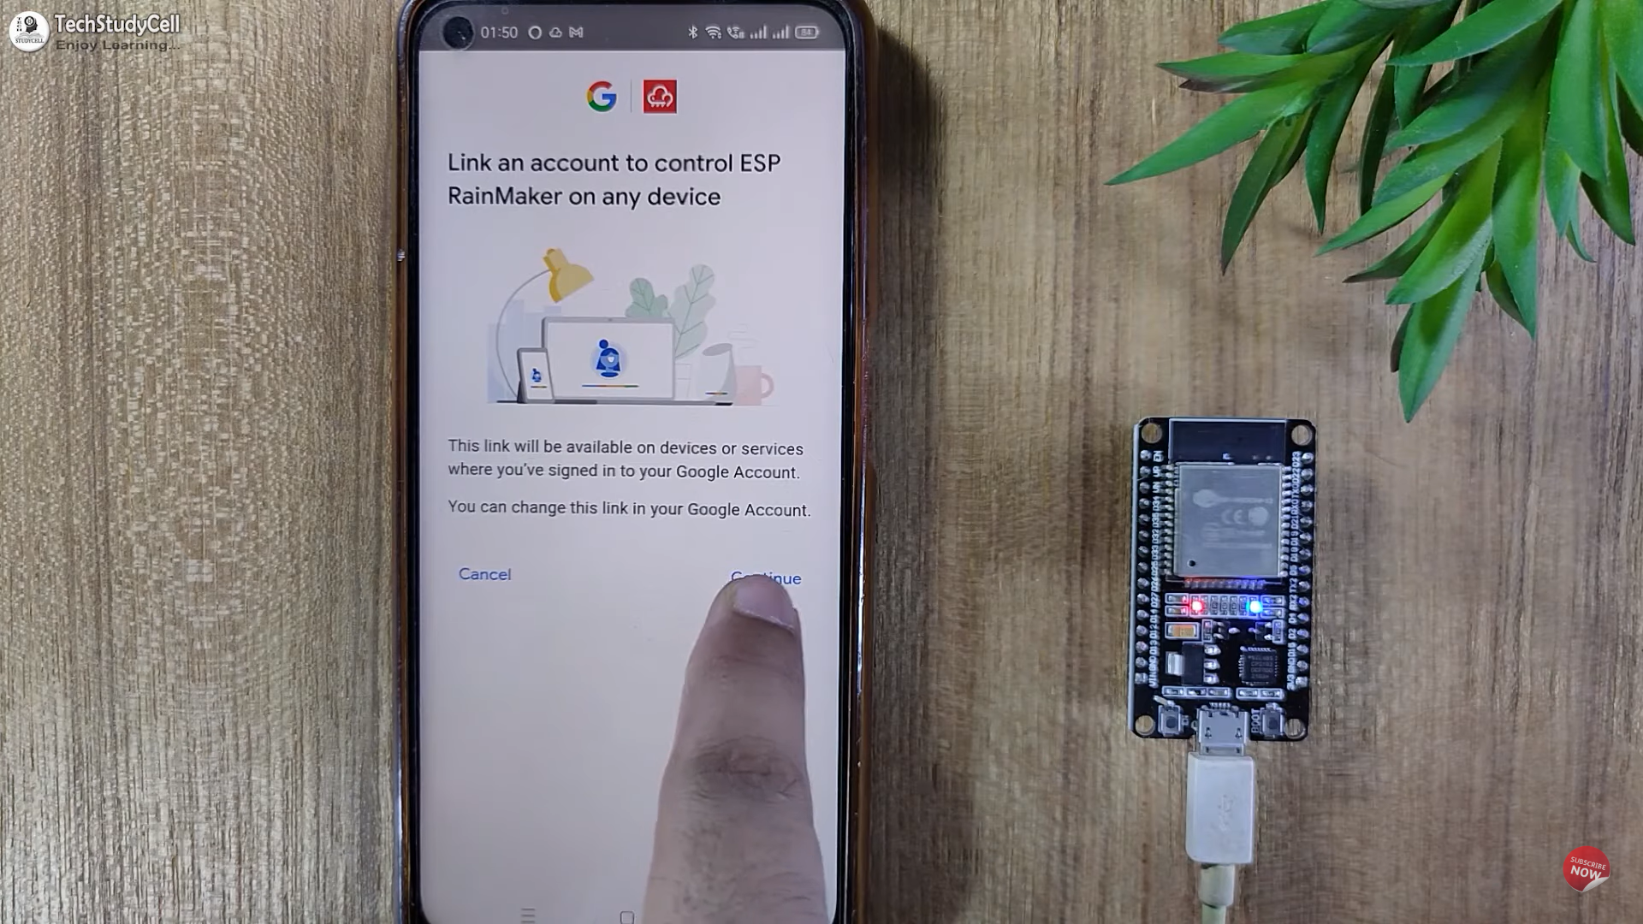

Fig.no Connecting this ESP rainmaker app with Google home app

1. Then you can control your home appliances by using voice command and also by using user interface of google home app.

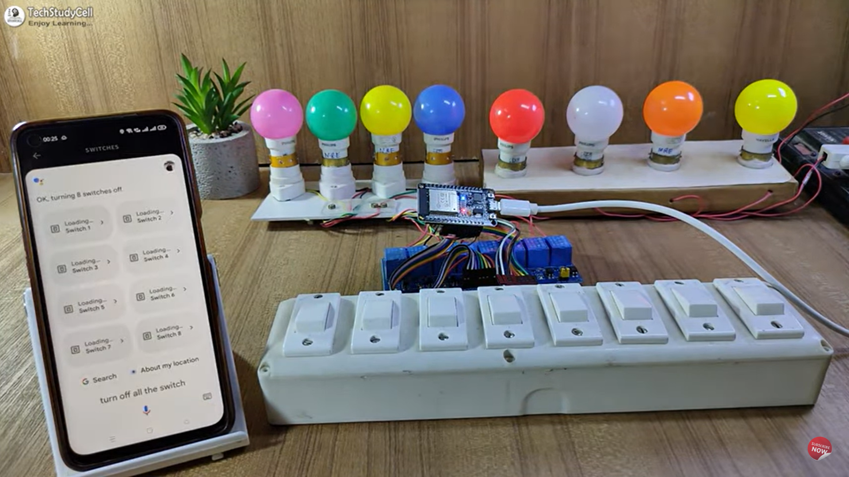 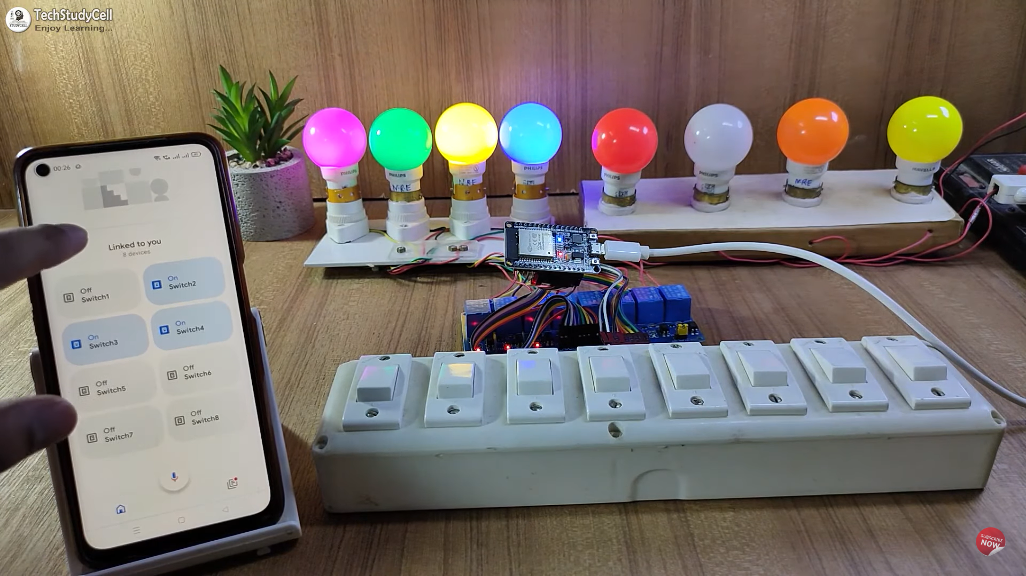

Fig.no controlling your home appliances google home

1. Now download the Amazon alexa app from app store/play store.

Download link

For android

<https://play.google.com/store/search?q=amazon%20alexa&c=apps>

For IOS <https://apps.apple.com/in/app/amazon-alexa/id944011620>

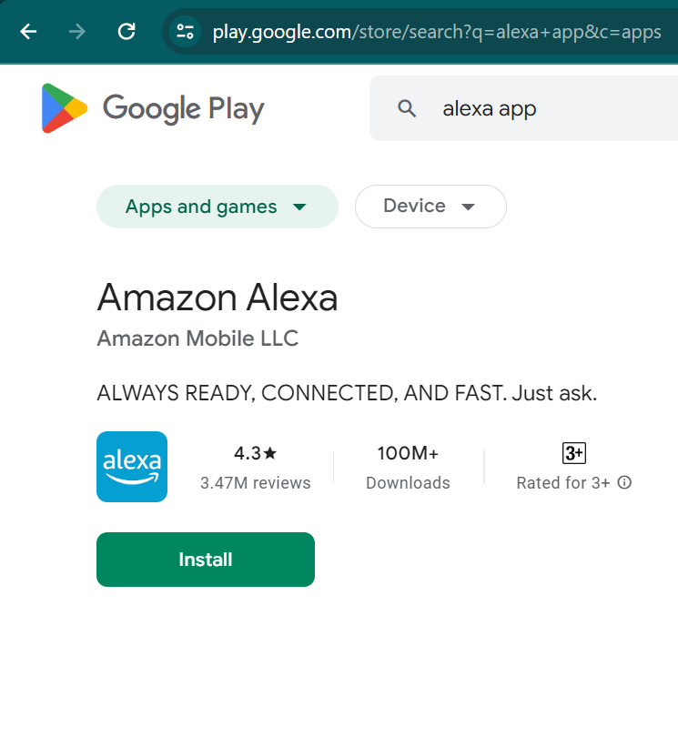 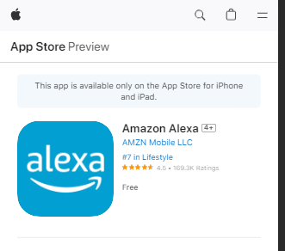

Fig.no Amazon Alexa android and IOS app

1. Connect amazon alexa app with ESP rainmaker app.

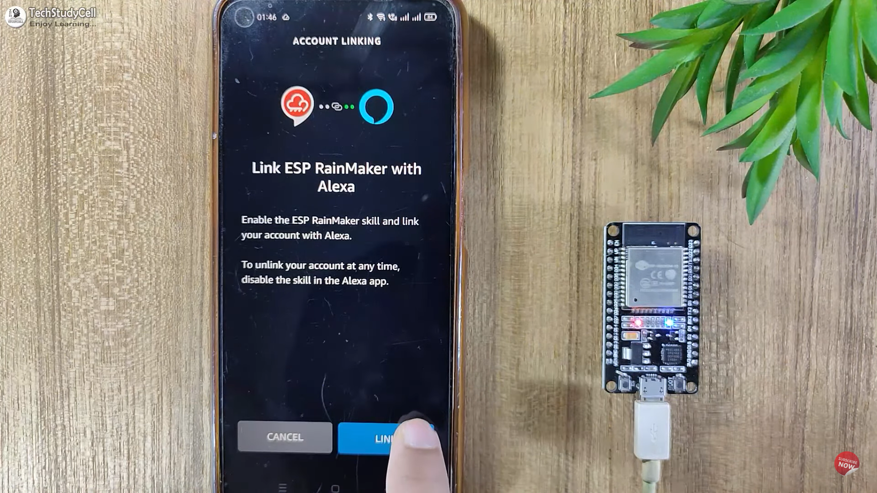

Fig.no Connecting amazon alexa app

1. After this you have one another option to control your home appliances by using you voice command and also by using UI of amazon alexa app.

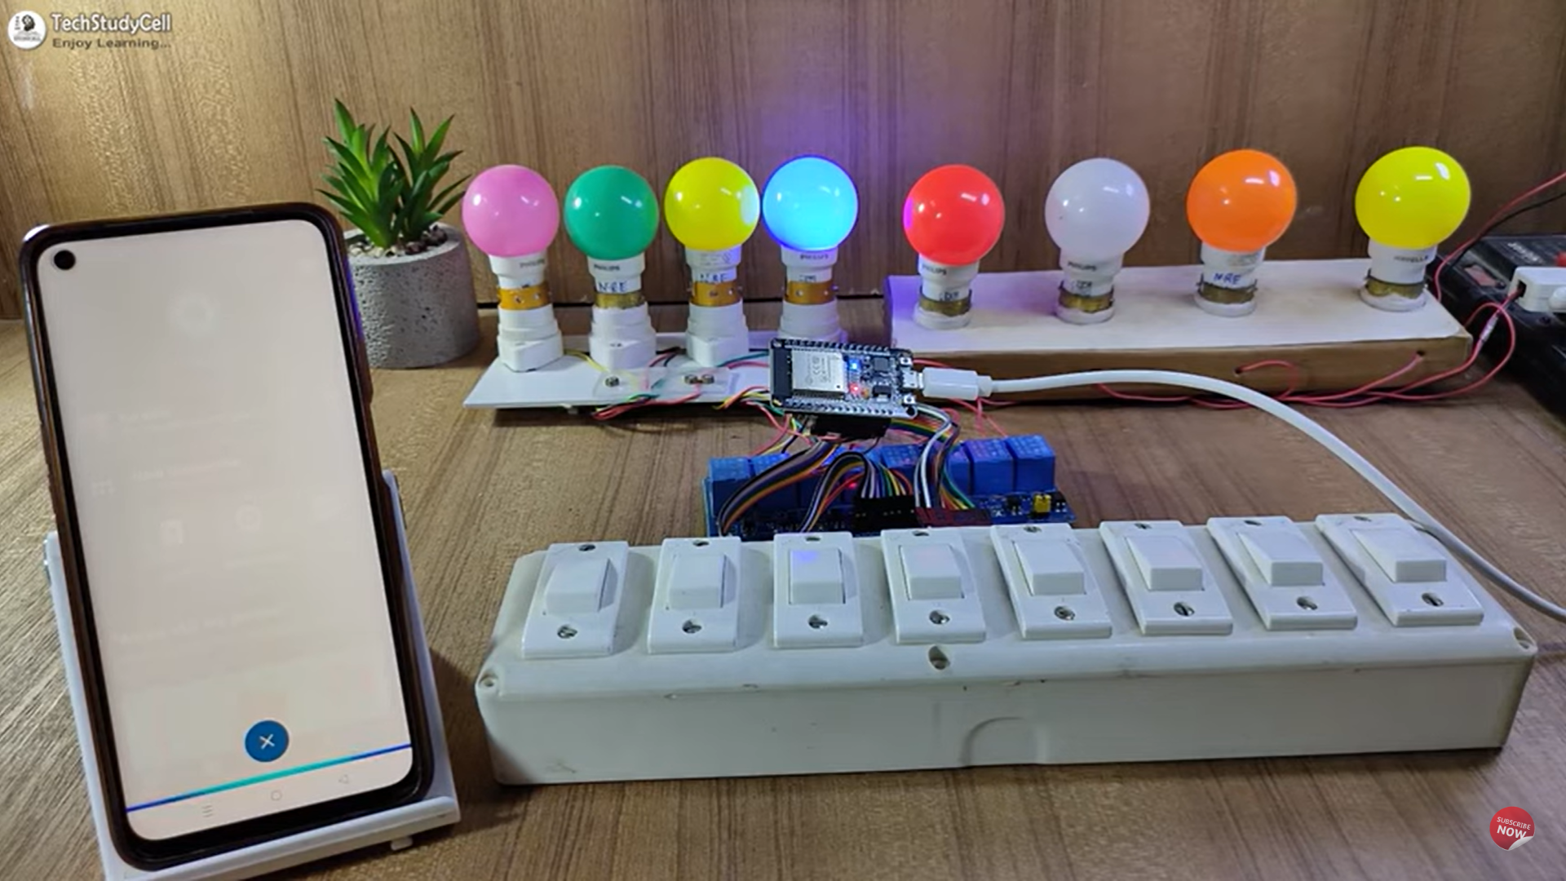 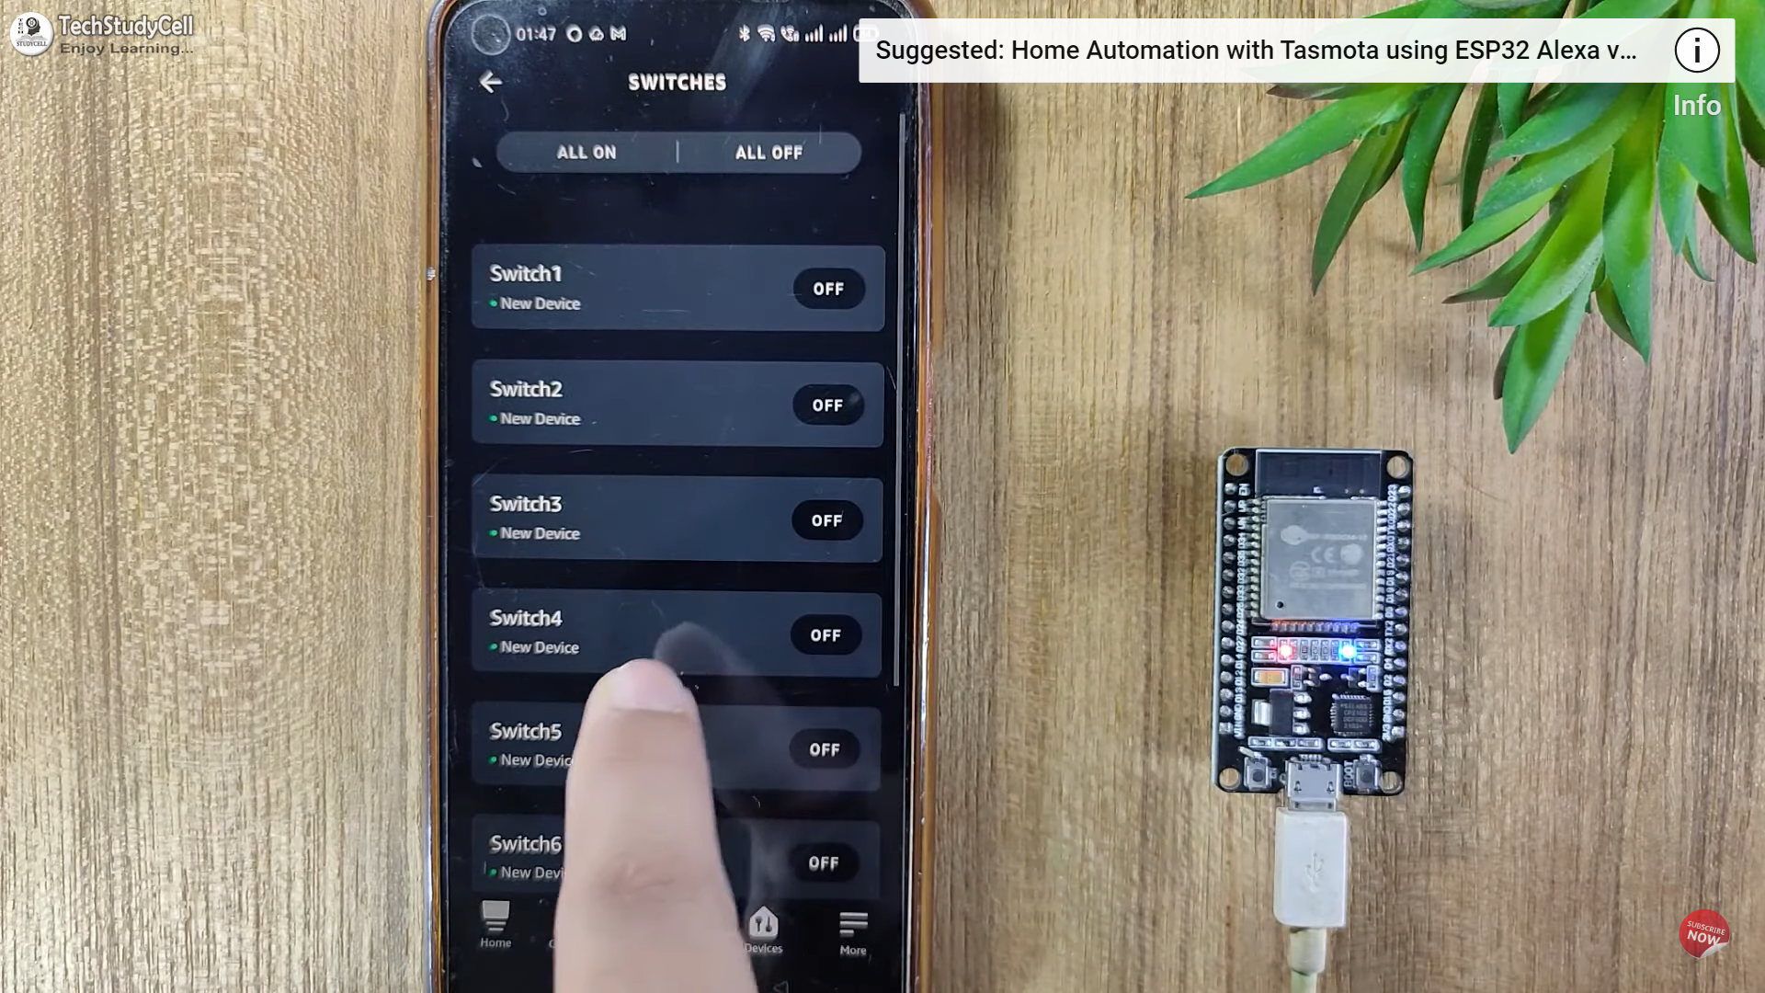

Fig.no controlling your home appliances Amazon alexa.

1. By using same steps you can prefer other option for controlling home appliances which is available in market.

# Flow Chart

## Flow Chart of controlling ESP32 from mobile phone UI.

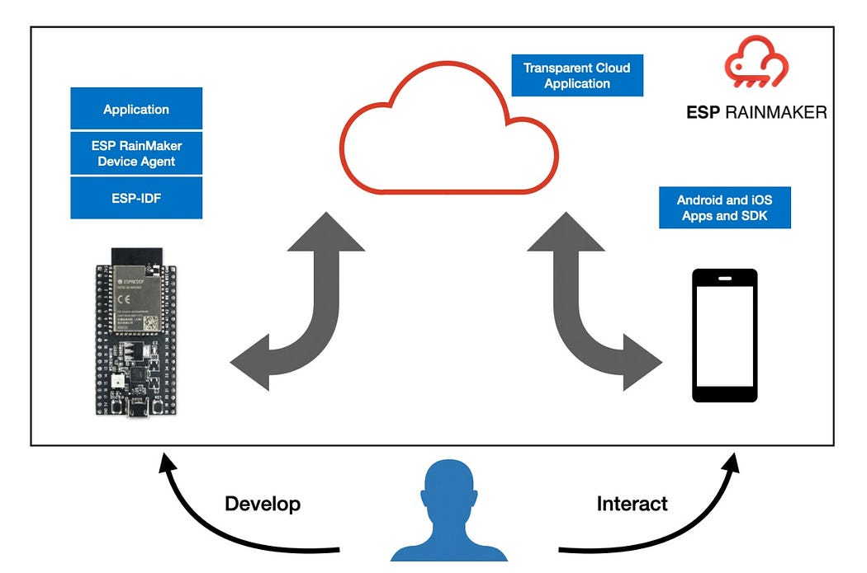

Fig.no controlling ESP32 from mobile phone UI

## Flow Chart of controlling ESP32 from mobile phone voice command.

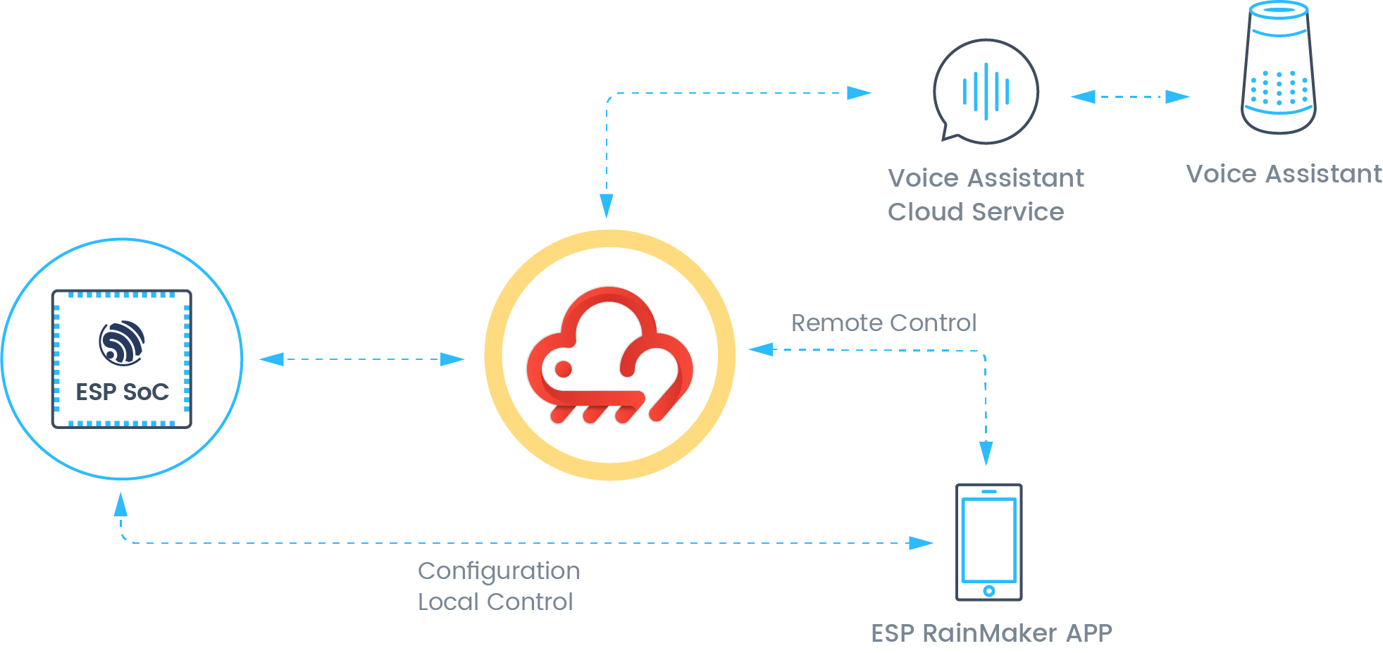

Fig.no controlling ESP32 from mobile phone voice command

## Complete Flow Chart of ESP Rainmaker

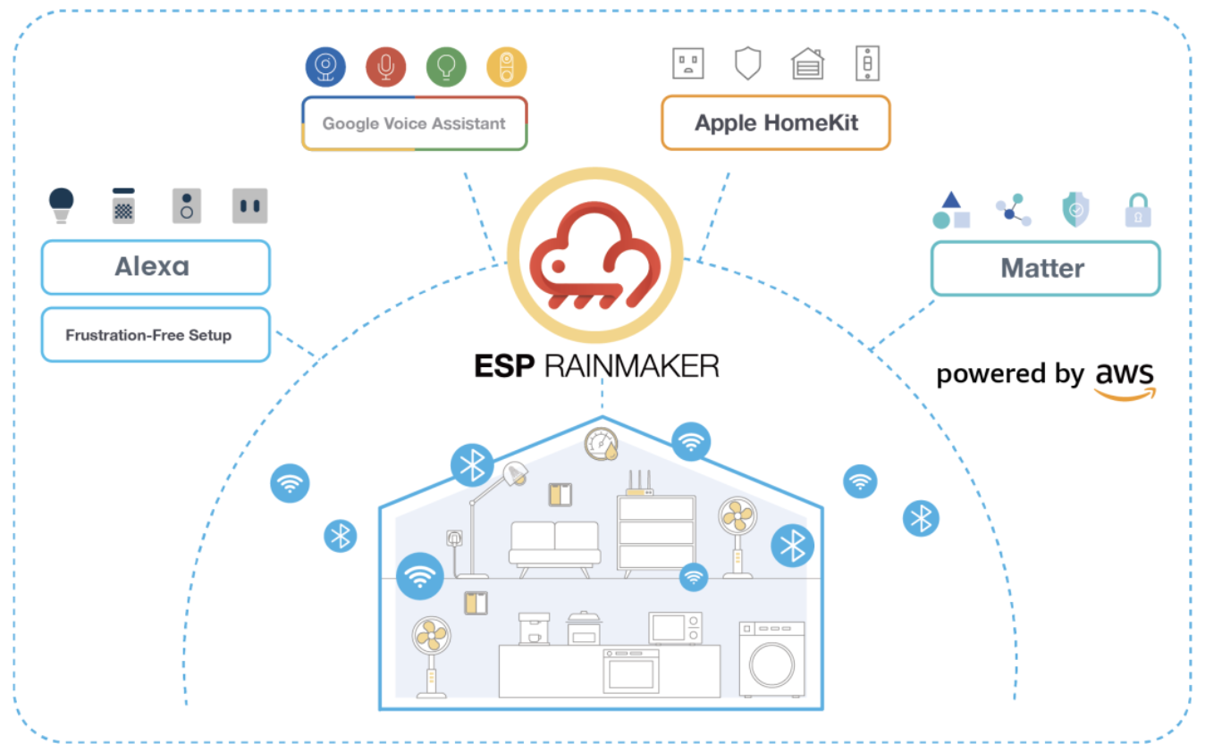

Fig.no Flow Chart of ESP Rainmaker

## Service Platforms

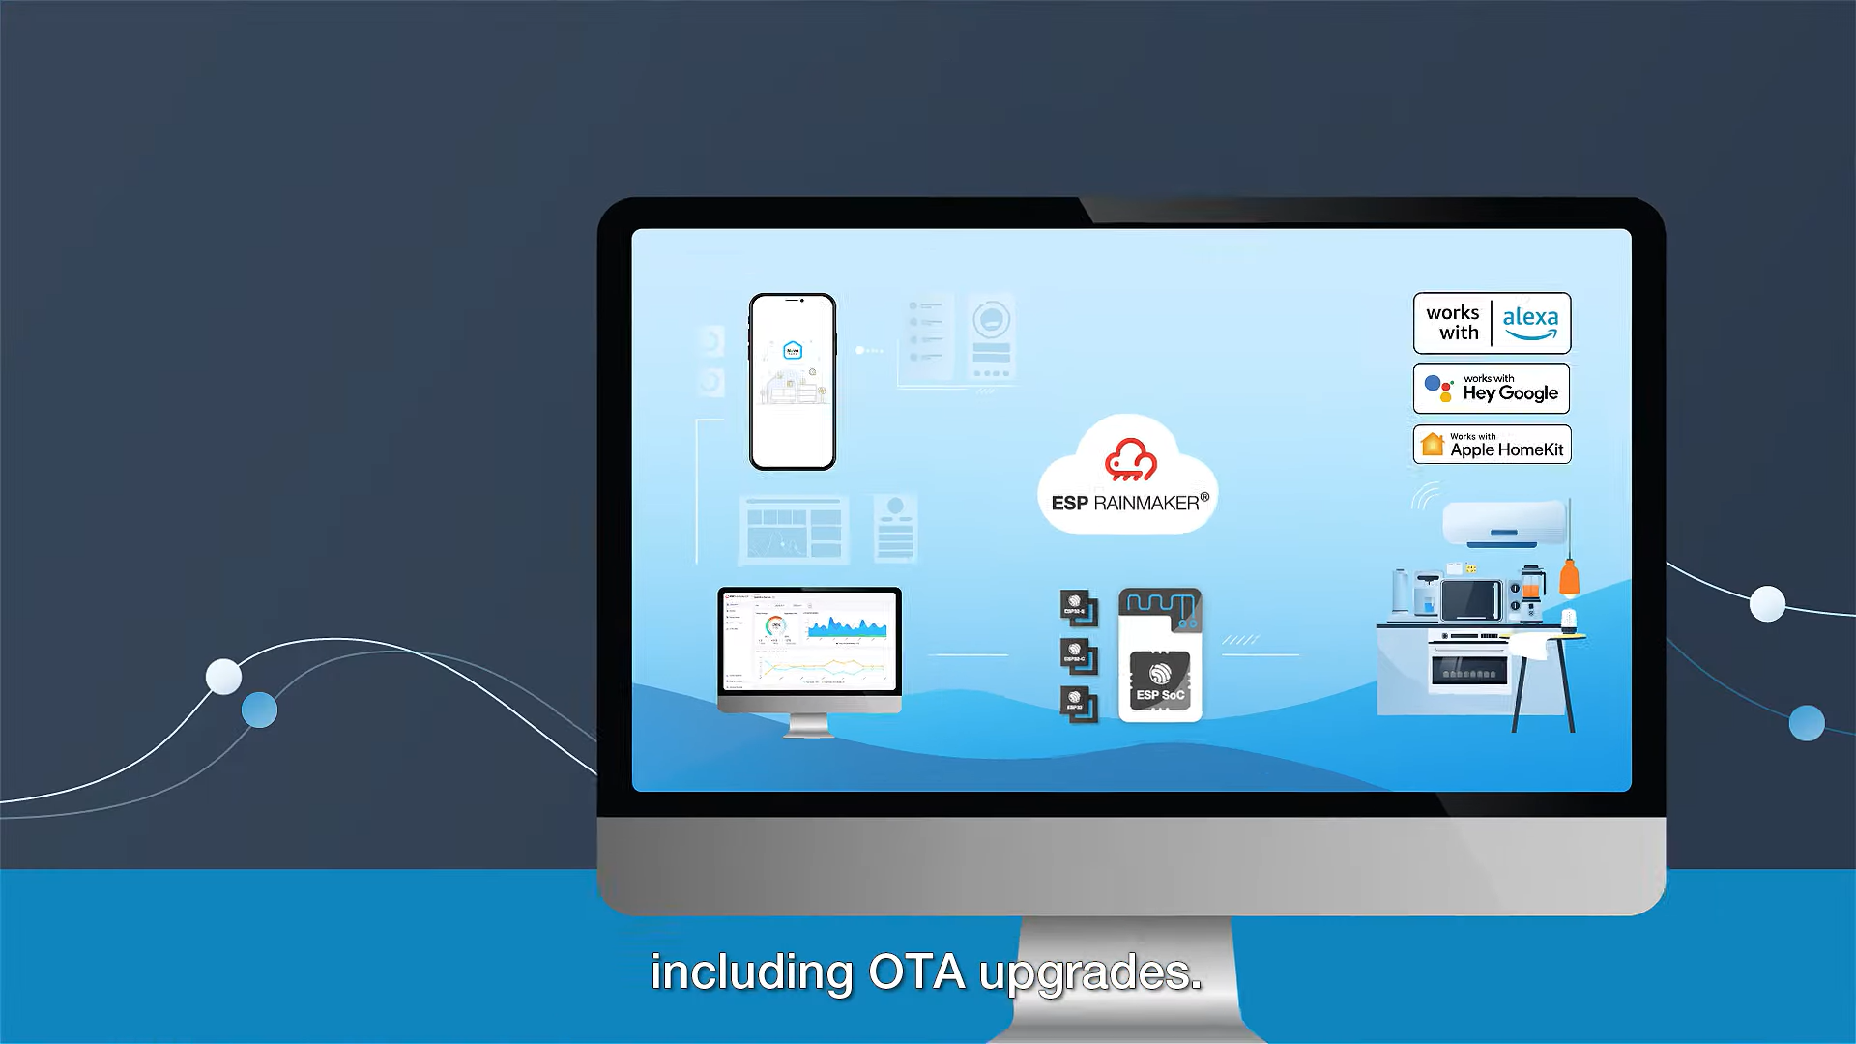

Fig.no Service Platforms

# Advantages

* Error probability reduced Ease of access and low cost and power consumption
* Can reduce human effort
* Smarter processing and services
* Can be implemented at any device and automated
* Alert system is quick in case of an emergency
* Eliminates the use of PC for automation
* Helps old age people to control the remote devices
* Simple interface

# Disadvantages

* Replacing humans is dangerous May take time and learning
* Security concerns
* Vulnerable to attacks Most of the times range is restricted
* High dependency on sensor devices which makes the system vulnerable if sensor fails

# Conclusion

In conclusion, the Home Automation System using IoT represents a paradigm shift in home management, offering users unprecedented control, efficiency, and security. This project serves as a testament to the transformative potential of IoT in shaping smarter and more connected living spaces.

# Reference

* Git Hub
* Esp 32 Module-<https://amzn.to/3ymRZcT>
* Relay Module 4 channel-<https://amzn.to/3yxxPNN>
* Manual switches -<https://www.amazon.in/dp/B08R5KNZWP/ref=sspa_dk_detail_2?pd_rd_i=B08R5KNZWP&pd_rd_w=Fb8EL&content-id=amzn1.sym.0fcdb56a-738b-4621-9da7-d47193883987&pf_rd_p=0fcdb56a-738b-4621-9da7-d47193883987&pf_rd_r=N8CGN9CNFDCX5EEDW9Q3&pd_rd_wg=jAMMX&pd_rd_r=218192bd-effe-4375-9b1b-c65107690419&s=industrial&sp_csd=d2lkZ2V0TmFtZT1zcF9kZXRhaWwy&th=1>
* LED Lights-<https://www.amazon.in/Philips-0-5-Decomini-Multicolor-Pack/dp/B01BGP193Y/ref=pd_vtp_h_pd_vtp_h_d_sccl_4/261-1852555-4406809?pd_rd_w=qixxP&content-id=amzn1.sym.6c9a4279-ad42-4fd6-b9a9-3cd14ede34c9&pf_rd_p=6c9a4279-ad42-4fd6-b9a9-3cd14ede34c9&pf_rd_r=FF75H7WS7W8XDJ1YPJY3&pd_rd_wg=1jV5s&pd_rd_r=3141cd6a-3b04-474b-a92d-047bbb66aaf2&pd_rd_i=B01BGP193Y&psc=1>
* Bulb Holders-<https://www.amazon.in/Duravolt-Polycarbonate-Capacity-220-240-Quality/dp/B09BFB4H8W/ref=sxin_15_pa_sp_search_thematic_sspa?content-id=amzn1.sym.3e281033-6906-4707-ac94-aef585daf496%3Aamzn1.sym.3e281033-6906-4707-ac94-aef585daf496&crid=SBL1TC9DK5XV&cv_ct_cx=bulb%2Bholders&keywords=bulb%2Bholders&pd_rd_i=B09BFB4H8W&pd_rd_r=51eb6e02-c758-47d8-9ded-0da0fa713331&pd_rd_w=iaNJb&pd_rd_wg=6WxCE&pf_rd_p=3e281033-6906-4707-ac94-aef585daf496&pf_rd_r=XK7CV00546Y7AADM9X29&qid=1703953435&s=industrial&sbo=RZvfv%2F%2FHxDF%2BO5021pAnSA%3D%3D&sprefix=bulb%2Bholders%2Cindustrial%2C289&sr=1-2-ced4eeeb-b190-41d6-902a-1ecb3fb8b7c4-spons&sp_csd=d2lkZ2V0TmFtZT1zcF9zZWFyY2hfdGhlbWF0aWM&th=1>